Episode 2: 1998: Mohammed
Unit focus: History
Year level: Years 3–6
Episode clip: Discrimination
Activity 3: Equality in sport
Subthemes: Culture; Entertainment and games; Gender roles and stereotypes
In Episode 2, Mohammed and Danielle discuss the school cricket tryouts. Danielle is passionate about wanting equality in team selection and voices her opinion about discrimination against girls who want to play in the school cricket team.
Discover
- Ask students to discuss gender equality in sports played at their school. They could record their responses to the following questions on a poster in the classroom:
- Are there teams for both girls and boys for every sport played at the school?
- Does the school offer mixed teams for sports?
- Do girls often try out for so-called 'boys' teams'?
- Have gender roles changed in sports at schools in the last ten years?
- Divide the class into small groups. Each group should research, and present, a report on one of the following teams:
- The Australian women's cricket team
- The Australian women's basketball team
- The Australian women's soccer team
- The Australian women's baseball team
- The Australian women's water polo team
- The Australian women's netball team
- The Australian women's volleyball team
- The Australian women's hockey team
- The Australian women's Rugby Union team
- The Australian women's Rugby League team
- Ask students to view the clip on Screen Australia digital learning, Women and sport in Australia, http://dl.screenaustralia.gov.au/module/1494/#about
- There is a range other information on the topic on The Australian Women's Register, http://www.womenaustralia.info
Reflect
- Student Activity Sheet H2.3 contains a Spider Map, which has headings that will assist students to organise their responses to the video clip.
Download
- Student Activity Sheet H2.3: Australian women in sport
Episode 3: 1988: Lily
Unit focus: History
Year level: Years 3–6
Episode clip: Food and chores
Activity 1: Fashions of the '80s
Subthemes: Fashion; Gender roles
The 1980s saw a buoyant economy that allowed families to afford the latest trends and technological advancements, such as microwave ovens, colour TVs and VHS players. Fashion reflected the notion that women could work as equals to men, and their clothes reflected a more businesslike approach, with bold fabrics, large jewellery and shoulder pads.
Discover
- Discuss the following questions:
- What factors inspired the fashion trends of the 1980s?
- Where did these trends originate?
- Why did Australians want to follow these trends?
- Ask students to find images of fashion items from the 1980s. These images can include clothing, footwear or accessories. The images can form a 1980s mural for the classroom. Discuss the main elements of fashion for men and women in the 1980s.
Reflect
- Ask students to create a fashion inspired by the 1980s. They should use the template provided and find colour and pattern swatches for the outfit.
- As a class, compile a list of the most popular clothing trends from the 1980s.
Download
- Student Activity Sheet H3.1: Fashion template
Episode 4: 1978: Mike
Unit focus: History
Year level: Years 3–6
Episode clip: The card collection
Activity 4: Migrant rights
Subthemes: Gender roles; Multiculturalism
The 1970s saw a groundswell of political activism in Australia on many fronts: the peace movement, environmental protection, feminism and workers' rights. The Galbally Review of Post-Arrival Programs and Services for Migrants opened the door to the idea of migrants' rights, a concept that paved the way for multiculturalism.
To learn about the struggle of migrant women during this era, go to eMelbourne: the city past and present, 'Migrant women and feminism', http://www.emelbourne.net.au/biogs/EM02141b.htm
Discover
- In this clip, the role of the women in Mike's family is clearly defined. Ask students to analyse the women in Mike's family, their roles and the differences in their roles.
Reflect
- Ask students to complete the 'historyface' template for the women in Mike's family: his grandmother (Yaya), mother (Janice) and aunt (Sofia). The students can share their findings with the rest of the class.
Download
- Student Activity Sheet H4.4: Mike's family profiles
Activity 5: Changes
Subthemes: Gender roles; Multiculturalism
Fashions of the 1970s extended the look established in the 1960s with the mini-skirt. Fashions for women became more daring and colourful, as 'mod', 'surfie', 'hippy' and 'disco' styles became fashionable. Fashions for men became more casual, pairing jeans with sandals, and flairs with platform shoes.
Discover
- Discuss the topic, 'How does fashion highlight the changing tastes in culture, attitudes and behaviour of each era?' and make a list of how fashion creates a 'point of view' in history.
- Use the following websites as stimulus:
- Macgregor State School, http://www.macgregoss.eq.edu.au/aussie.htm
- Vintage Now, http://www.vintage-now-clothing.com
- Rusty Zipper, http://www.rustyzipper.com
- Google Images, http://images.google.com.au
- Ask students to talk with their parents about fashion in the 1970s. They could bring some photos or original outfits belonging to their parents and share these with the class.
Reflect
- Ask students to use the body template in Student Activity Sheet H4.5 to create three different 1970s outfits using paper and fabric. A photo of the student's face can be added to the template to personalise it. Upload the images to the school website as an album of 1970s fashion.
Download
- Student Activity Sheet H4.5: Fashion of the 1970s
Episode 7: 1948: Jen
Unit focus: History
Year level: Years 3–6
Activity 7: The baby boom
Activity 8: Changes
Subthemes: Gender roles and stereotypes; Relationships
Discover
- Jen has experienced many changes in her family. She lost her war-hero father, is living with her extended family and is getting a new stepfather. Her mother also experiences considerable changes; she is now a young widow with a child to support, relies on her family for help, and has to share her house. Following the war, it was common for young war widows to remarry.
Reflect
- As a class, discuss the changing roles of women in post-war Australia and the effects this had on society. Students could investigate women's roles in the 1940s compared with the roles of women today. They should look at women's responsibilities in the home, at work and in the community. Then the class can create a Venn diagram to visually represent this comparison.
Download
- Student Activity Sheet H7.8: Comparing women's roles
Episode 10: 1918: Bertie
Unit focus: History
Year level: Years 3–6
Activity 5: Prejudice
Subthemes: Australians at war; Gender roles and stereotypes;
Indigenous perspectives
Indigenous Australians have served in all conflicts undertaken by the Australian Defence Forces, even when denied rights such as the right to vote in many states and territories, or access to the returned servicemen's pension.
Discover
- Ask students: what would it feel like to be discriminated against? Discuss this concept and ask students to draw on any personal experiences they may have of being discriminated against. Use a Y-Chart to express their view on the following focus questions:
- What does discrimination look like?
- What does discrimination feel like?
- What does discrimination sound like?
Reflect
- Students watch the clip 'Impact of war' again, this time focusing on the body language and voices of Bertie, Sid and Mr Watson. Using the Student Activity Sheet provided, they should respond to the questions on what discrimination looks like and sounds like, using examples observed in the clip. All responses can be shared with the class.
Download
- Student Activity Sheet: H10.5: Discrimination conflict wheel
Episode 11: 1908: Evelyn
Unit focus: History
Year level: Years 3–6
Episode clip: Games from India
Activity 3: Fashions for children
Subthemes: Fashion; Gender roles and stereotypes
The characters in this episode wear costumes typical of fashions in 1908. Evelyn wears a modest dress of cotton or gingham with long sleeves, a full skirt and a hemline above the ankles. Edward and Freddie wear white shirts, ties, vests, shorts and work boots.
Discover
- Ask students to compare the fashions in the clip with the fashions of children today. For more in-depth information, students can conduct research in the school or local library, or online.
As a starting point, refer to the websites listed below:
- Wikipedia, '1900s in fashion', http://en.wikipedia.org/wiki/1900s_in_fashion
- Fashion-Era, 'Children's Costume History 1900 to 1910', http://www.fashion-era.com/Childrens_clothes/1900_1910_girls_costume_pictures.htm
- The Costume Gallery's Online Library, 'McCall's Magazine: May 1908', http://www.costumegallery.com/McCalls/May_1908/Month.htm
- Students should choose a character from the episode, draw them a costume, name the parts of the costume and describe why they wore this attire. Ask students to design another costume for their chosen character and explain why they have dressed them this way. They could cut out their character as a paper-doll pattern and dress the doll in the new costume using paper tabs. As an alternative, students could use card and magnets to make the designs into paper dolls that they can display on a magnetic surface.
Download
- Student Activity Sheet H11.3: Paper-doll costumes
Episode clip: Chores and punishment
Activity 11: Chores
Subthemes: Chores, business and employment; Gender roles
Education for girls was still very limited in the 1900s. It was an expectation that girls helped their mothers at home so that they would learn how to run their own household when they got married. In this clip, we see Evelyn completing two chores: polishing the silver cutlery and waxing the table.
Discover
- What chores would children be expected to do in 1908? Students could develop two lists headed 'Chores for girls' and 'Chores for boys'. Compare the lists. What do the two lists show us about life for each gender in this era?
- A useful starting point for research is:
State Library of South Australia, 'SA Memory: Collecting Firewood', http://samemory.sa.gov.au/site/page.cfm?c=7191
- Ask students to select a character from this episode and write a journal entry for a day in the life of the character. They should include everything that they do within one 24-hour period.
Download
- Student Activity Sheet H11.10: Comparing chores
Episode 13: 1888: Victoria
Unit focus: History
Year level: Years 3–6
Episode clip: Victoria's family supper
Activity 4: The 'It girls'
Subthemes: Fashion; Gender roles and stereotypes
Character profiling can highlight the historical significance of a person's attire. Costumes, work attire and everyday clothing are the pictorial benchmark of an era.
Focus discussion on the characteristics of the Owen girls and the members of Victoria's family. Also note some of the other characters in the episode, for example, Miss Müller. The pop culture idea of an 'It girl' can help students understand why the focus on clothes is important in determining historical status.
Discover
- What makes an It girl in 1888?
Reflect
- Ask students to create character profiles using names, birthdates, descriptions and clothing from 1888. Websites to use include:
- Picture Australia, http://pictureaustralia.org/trail/fashion+trail
- Eureka Council, http://www.eurekacouncil.com.au/Australian-Culture/australian-fashion.htm
- Victorians Fashion Australia, http://www.ulladulla.info/fhc/vicfashions.htm
- Collections Australia: http://www.collectionsaustralia.net/collections
- Students create a character profile using different software programs.
Download
- Student Activity Sheet H13.5: Historical character profile
Episode clip: Victoria's family supper
Activity 7: Working women
Subthemes: Chores, business and employment; Gender roles
Discover
- What was the common view of women going to work in the 1880s? Research what employment women undertook in 1888. Compare the types of employment to the careers of women today.
Reflect
- View the clip and ask students to listen to the attitude of Victoria's mother to Miss Müller working. Ask them to create two journal entries: one for a day in the life of Miss Müller and one for a day in the life of Victoria's mother.
- Students compare these to a day in the life of their own mother or female relative.
Download
- Student Activity Sheet H13.8: Women's roles in 1888

Student Activity Sheet H2.3 |  | Episode 2: 1998: Mohammed
Activity 3: Equality in sport |  | Clip: Discrimination
Australian women in sport
- View the following clip from the Screen Australia website: Women and Sport in Australia, http://dl.screenaustralia.gov.au/module/1494/#about
- Use the spider map below to record your ideas and opinions after viewing the clip. The topic is written in the middle of the spider map. Add the main ideas on the lines radiating out from the centre. Write further details on the horizontal lines.

Spider map
Write main ideas on the slanted lines that connect to the circle. Write details on the branching lines.
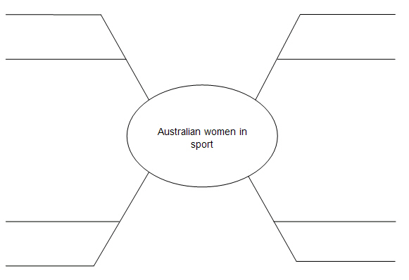
Student Activity Sheet H3.1 |  | Episode 3: 1988: Lily
Activity 1: Fashions of the '80s |  | Clip: Food and chores
Fashion template
- Create a fashion look inspired by the 1980s. Use the template below to create an outfit. You can use a variety of fabric swatches or coloured paper. Once you have completed your outfit, share it with the class.
- Compile a list of the most popular clothing trends from the 1980s.
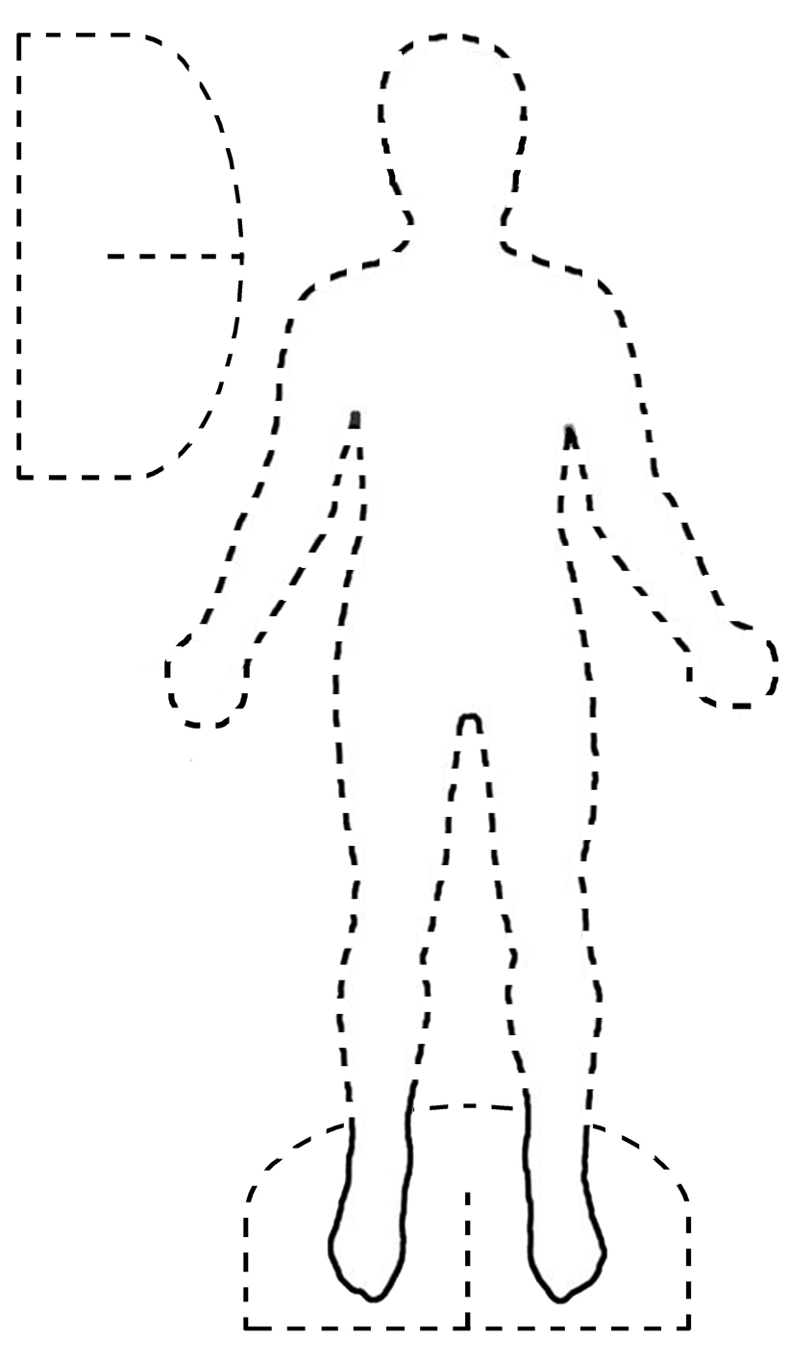

Student Activity Sheet H4.4 |  | Episode 4: 1978: Mike
Activity 4: Migrant rights |  | Clip: The card collection
Mike's family profiles
Complete this 'historyface' for the women in Mike's family: his grandmother (Yaya), mother (Janice) and aunt (Sofia).
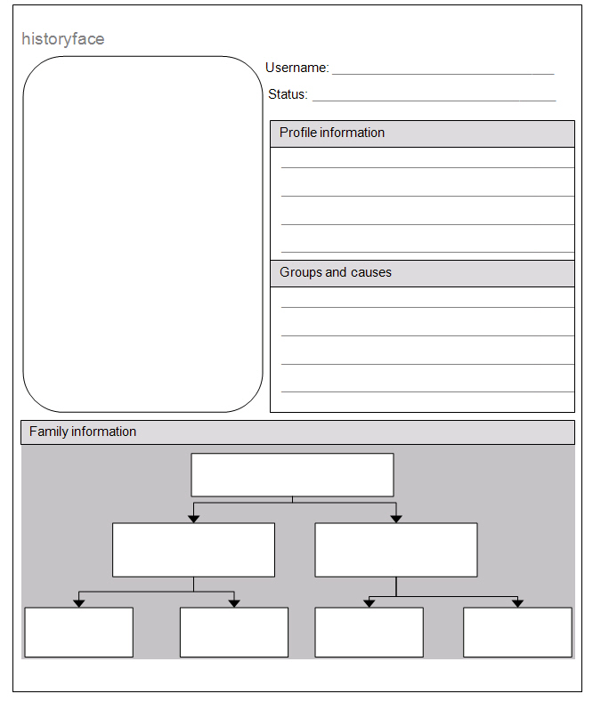

Student Activity Sheet H4.5 |  | Episode 4: 1978: Mike
Activity 5: Changes |  | Clip: The card collection
Fashion of the 1970s
Use the template below to create three different outfits inspired by the 1970s. Use paper and fabric to create your items of clothing. Make sure you add tabs to the clothes so you can attach them to the template. The result will be a paper doll with three different outfits.
The outfits must be made to fit the size of the template. You can paste a photo of your face and add it to the template.

Student Activity Sheet H7.8 |  | Episode 7: 1948: Jen
Activity 8: Changes |  | Clip: Courting
Comparing women's roles
Compare women's responsibilities in the home, at work and in the community in the 1940s and today. Use the Venn diagram to visually represent the different and shared features.
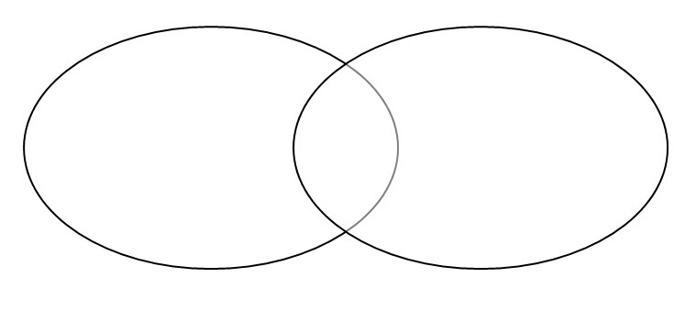
Women's roles: 1940
Shared features
Women's roles: today

Student Activity Sheet: H10.5 |  | Episode 10: 1918: Bertie
Activity 5: Prejudice |  | Clip: Impact of war

Discrimination conflict wheel
Use the conflict wheel below to record how the characters in the clip 'Impact of war', deal with discrimination. Watch the clip and write down your thoughts on how each character responds with actions and words.
Conflict wheel
Actions
Actions
Bertie
Sid
Mr Watson
Words
Words
Words
Actions

Student Activity Sheet H11.3 |  | Episode 11: 1908: Evelyn
Activity 3: Fashions for children |  | Clip: Games from India
Paper-doll costumes
Create your own outline of a paper doll and make costumes to fit it. The paper doll and costumes can be made using cardboard or felt. You can also create paper dolls on magnetic sheets so that they stick onto a whiteboard or other magnetic surface.
- Dress the doll in the fashions that you would find Evelyn and her siblings wearing.
- Design your own clothes for this era and dress the dolls in these.
Student Activity Sheet H11.10 |  | Episode 11: 1908: Evelyn
Activity 11: Chores |  | Clip: Chores and punishment
Comparing chores
- Write a list of the typical chores that boys and girls in 1908 had to do on a daily basis. Watch this episode of My Place carefully and take notes to help you compile the list.

Chores for boys in 1908 | Chores for girls in 1908

- Discuss the differences in the chores with other students in your class.
- Select a character from this episode of My Place and write a journal entry for a day in the life of the character. You can use the 'Dear Diary' template on the next page.

Student Activity Sheet H11.10 |  | Episode 11: 1908: Evelyn
Activity 11: Chores |  | Clip: Chores and punishment
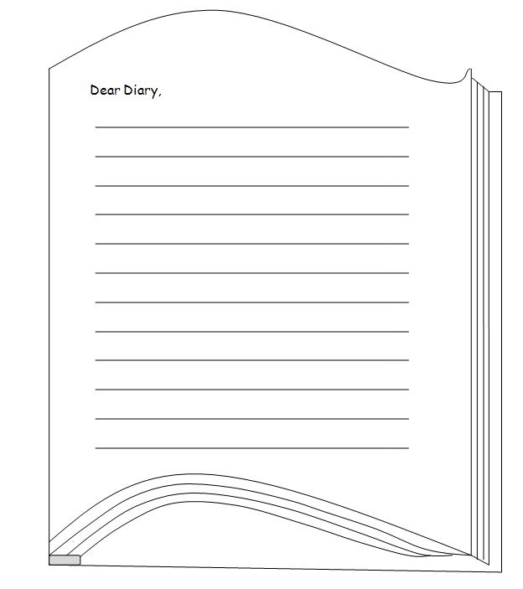

Student Activity Sheet H13.5 |  | Episode 13: 1888: Victoria
Activity 4: The 'It girls' |  | Clip 2: Victoria's family supper
Historical character profile
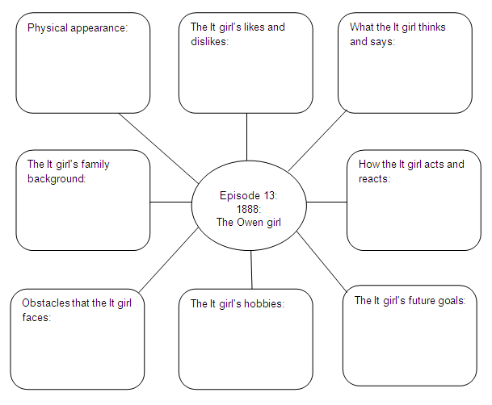

Student Activity Sheet H13.8 |  | Episode 13: 1888: Victoria
Activity 7: Working women |  | Clip 2: Victoria's family supper
Women's roles in 1888
Journal entries: A day in the life of ...
- Write reflective journal entries from the point of view of Miss Müller and Victoria's mother in Episode 13. They are two very different characters. Think about their lifestyles and make reference to events that occur in their daily lives.
Victoria's mother

Miss Müller

