Episode 20 | 1818: Charles
Unit focus: History
Year level: Years 3–6
Episode clip: Fencing
Activity 1: Escape!
Subthemes: Culture; Gender roles and stereotypes; Historical events
The remoteness of Australia and its formidable landscape and harsh climate made this alien land an ideal choice as a penal settlement in the early 19th century. While the prospect of escape may initially have seemed inconceivable, the desire for freedom proved too strong for the many convicts who attempted to flee into the bush. Early escapees were misguided by the belief that China was only a couple of hundred kilometres to the north. Later, other convicts tried to escape by sea, heading across the Pacific Ocean. In this clip, Charles meets Liam, an escaped convict who is attempting to travel over the Blue Mountains to the west.
Discover
- Ask students to research the reasons why Australia was selected as the site of a British penal colony. They should also find out who was sent to the colony and where the convicts were first incarcerated. Refer to the My Place for Teachers, Decade timeline – 1800s for an overview. Students should write an account of the founding of the penal settlement in New South Wales.
- As a class, discuss the difficulties convicts faced when escaping from an early Australian gaol. Examine the reasons they escaped and the punishments inflicted when they were captured. List these reasons and punishments on the board or interactive whiteboard.
- For more in-depth information, students can conduct research in the school or local library, or online. As a starting point, refer to the resources listed below:
- Hirst, W 1999, Great Convict Escapes in Colonial Australia, Kangaroo Press, Sydney
- Convict Creations, 'Convict Escape Attempts', www.convictcreations.com/history/escapes.htm
- State Library of New South Wales, 'On the Run: Daring Convict Escapes', www.sl.nsw.gov.au/events/exhibitions/2006/ontherun/
- State Library of New South Wales, 'On the Run: Daring Convict Escapes', Exhibition guide, www.sl.nsw.gov.au/events/exhibitions/2006/ontherun/docs/ontherun_guide.pdf
Reflect
- Ask students to select one of the convicts listed below, and research their story of escape:
- Mary Bryant (1765–date of death unknown)
- William Buckley (1780–1856)
- Martin Cash (1808–1877)
- John Graham (aged 12, transported in early 1840)
- Alexander Pearce (1790–19 July 1824)
- John Porter (transported 20 November 1818)
- William Swallow (1807–date of death unknown)
- Their individual research should gather information on the escapees about:
- their life prior to being a convict
- their experiences as a convict
- how they escaped
- consequences of their escape.
- Students can use Student Activity Sheet H 20.1 Escape! to organise their notes and write a diary entry.
- Ask students to work individually to write a diary entry imagining that they are their selected convict on the night before their escape. The entry should outline:
- the reasons why they are escaping
- their plan of escape
- their fears of what might happen to them if recaptured or lost in the bush.
- To give the diary entry an appearance of being artificially 'aged', paint the page with a mixture of instant coffee granules and water. The diary entries can be shared with the rest of the class and displayed in the classroom.
Download
- Student Activity Sheet H20.1: Escape!
Aligned resources
Hirst, W 1999, Great Convict Escapes in Colonial Australia, Kangaroo Press, Sydney
Convict Creations, 'Convict Escape Attempts', www.convictcreations.com/history/escapes.htm
State Library of New South Wales, 'On the Run: Daring Convict Escapes', www.sl.nsw.gov.au/events/exhibitions/2006/ontherun/
'On the Run: Daring Convict Escapes', Exhibition guide, www.sl.nsw.gov.au/events/exhibitions/2006/ontherun/docs/ontherun_guide.pdf
Useful resources from Education Services Australia
R11715 'The extraordinary tale of William Buckley', 2009: Escape from Sullivan Bay

Student Activity Sheet H20.1 |  | Episode 20: 1818: Charles
Activity 1: Escape! |  | Clip: Fencing
Escape!
- From the list below, select a convict whose story of escape appeals to you:
Mary Bryant | Alexander Pearce
William Buckley | John Porter
Martin Cash | William Swallow
John Graham
Research the convict and find out information about their escape from prison. Complete the sections of the table below with your notes about the convict.
Convict's name:
Information about the person prior to being a convict
Experiences as a convict
(What was life as a convict like for this person?)
How the convict escaped
(What was their method of escape? Where did they go?)
Consequences of their escape
(Were they captured and punished or did they achieve freedom?)
- Write a diary entry as though you are your convict on the night before your escape. Your entry should mention:
- the reasons why you are escaping
- your plan of escape
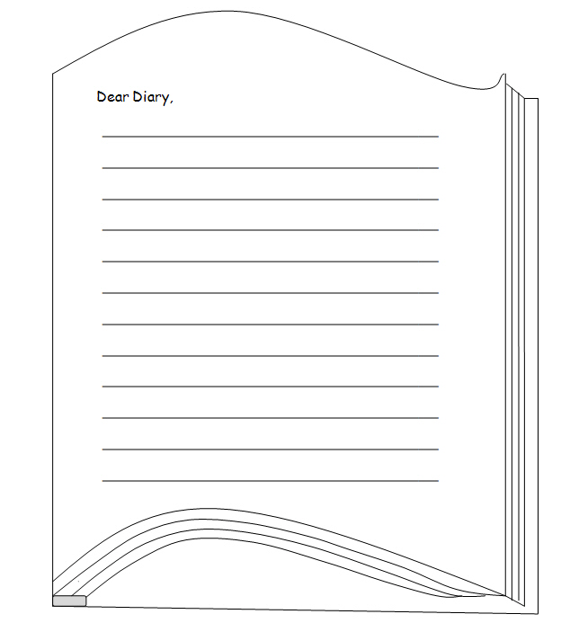
- your fear of what might happen if you are recaptured or lost in the bush.

Episode clip: Fencing
Activity 2: Schooling in the colony
Subthemes: Historical events; Social order and education
In this clip, Charles and his brother John help out on the farm before they are sent back to England to go to school. In Britain at this time, universal education was not the responsibility of the government. The early Australian governors, however, considered the education of young children an important step towards the success of the colony. They believed that schooling would teach the children of emancipated convicts to respect the law and become useful members of society. Governor Macquarie established the first public charity school in Sydney, attended by children of the poorer settlers. By 1821, with Macquarie's support, 15 public charity schools had been established in Sydney and outlying areas such as Parramatta, Liverpool, Windsor, Wilberforce and Richmond.
Discover
- Ask students to research information about the schools established by Governor Macquarie during his governorship. Students could find information in the school or local library, or online. As a starting point, refer to the websites below:
- New South Wales Department of Education and Training, 'Macquarie 2010', Life and Times – Schooling, http://lrrpublic.cli.det.nsw.edu.au/lrrSecure/Sites/Web/macquarie2010/macquarie2010/lo/life_and_times/index.htm?Signature=%2875c61db9-6cf0-4052-ae82-19e512827c1d%29
- State Library of New South Wales, 'The Governor: Lachlan Macquarie 1810 to 1821', Education and Welfare, www.sl.nsw.gov.au/events/exhibitions/2010/governor/education/
- Ask students to develop a profile of Governor Macquarie's achievements and vision for the colony. They could present the profile as a Facebook page, a promotional pamphlet for Macquarie in a state election or a report for the local newspaper.
Reflect
- Ask students to investigate the history of their own school. Their investigation should include drawing a map of their school in its earliest incarnation and a map of the school in the present.
- Students could construct a historical tour of the school. In small groups they could design a map and/or tour that include notes on historical features such as foundations, plaques on buildings, memorial gardens and the remains of earlier structures. Where available, mark the construction dates of buildings on the map.
- Students could find old photos and maps of the school for this historical tour in their local or school library. They should also draw a timeline of the development of the school, recording when the school was founded and when important buildings were constructed.
- Students with access to Kahootz 3 software could design an animated virtual tour of the school, which could be uploaded to the school website. Kahootz has capacity to import sound and this tour could be narrated.
Download
Student Activity Sheet H 20.2: Schooling in the colony
Aligned resources
Australian Children's Television Foundation, 'Kahootz 3', www.kahootz.com/kz/
New South Wales Department of Education and Training, 'Macquarie 2010', Life and Times – Schooling, http://lrrpublic.cli.det.nsw.edu.au/lrrSecure/Sites/Web/macquarie2010/macquarie2010/lo/life_and_times/index.htm?Signature=%2875c61db9-6cf0-4052-ae82-19e512827c1d%29
State Library of New South Wales, 'The Governor: Lachlan Macquarie 1810 to 1821', Education and Welfare, www.sl.nsw.gov.au/events/exhibitions/2010/governor/education/

Student Activity Sheet H20.2 |  | Episode 20: 1818: Charles
Activity 2:Schooling in the colony |  | Clip: Fencing
Schooling in the colony
- Develop a profile of Governor Macquarie's achievements and visions for the colony. You can present the profile as a Facebook page, a promotional pamphlet for Macquarie in a state election or a report for the local newspaper. Draft your ideas below:

- Research the history of your school. In particular, find out when the first buildings were completed and when the first students were enrolled. Draw a map of the school as it was in the beginning. Indicate on the map where you would find the foundations, plaques on buildings, memorial gardens and the remains of earlier structures. Where available, mark the construction dates of buildings on the map.
- Draw a map of your school as it appears today. On the map mark when each building was erected and what each building is used for today.
- Draw a timeline of the development of your school, recording when the school was founded and when the important buildings were constructed. Include some photos of the buildings as they appeared in the past and as they appear today.

Episode clip: The convict
Activity 3: Convict clothing
Subthemes: Character; Historical events
Convicts transported to the colonies of Australia experienced many hardships, including inadequate clothing. Shortages in the supply of penal uniforms made it hard for governors of New South Wales to regulate convict dress and as a result it was often hard to distinguish convicts from free working settlers. Socks were in such short supply that convicts – and soldiers – devised 'toe-rags' to ease the discomfort of state-issued shoes which did not distinguish between the right and left foot. No wonder the escaped convict Liam is so keen to get a pair of boots from Charles!
Discover
- Ask students to research the provisions supplied to convicts. They could research using the web or books from the library. As a starting point, refer to the websites below:
- Convict Creations, 'Descriptions of Convict Life', www.convictcreations.com/history/description.htm
- Convicts to Australia, members.iinet.net.au/~perthdps/convicts/
- Pilot guides, 'Pilot Destinations', Convict Australia: Convict Life, www.pilotguides.com/destination_guide/pacific/australia/convict_australia/convict_life.php/
- As a class, ask students to list the good and bad aspects of life for a transported convict in Australia.
Reflect
- Ask students to work in small groups and undertake a web quest. A web quest is where you search for images and descriptions of articles of clothing, noting the URL source of each image. Ask students to consider why each item of clothing was issued to convicts, and why it was designed to appear as it did. As a starting point, refer to the websites below:
- Powerhouse Museum, 'Convict', www.powerhousemuseum.com/collection/database/subject=Convicts
- Queen Victoria Museum and Art Gallery, 'Tasmanian Convict Costume', www.qvmag.tas.gov.au/?articleID=556
- Ask each group to present the images they have found in a slideshow presentation to the class.
Download
Student Activity Sheet H20.3: Convict clothing
Aligned resources
Convict Creations, 'Descriptions of Convict Life', www.convictcreations.com/history/description.htm
Convicts to Australia, members.iinet.net.au/~perthdps/convicts/
Pilot guides, 'Pilot Destinations', Convict Australia: Convict Life, www.pilotguides.com/destination_guide/pacific/australia/convict_australia/convict_life.php/
Powerhouse Museum, 'Convict', www.powerhousemuseum.com/collection/database/subject=Convicts
Queen Victoria Museum and Art Gallery, 'Tasmanian Convict Costume', www.qvmag.tas.gov.au/?articleID=556
Useful resources from Education Services Australia
L359 Samuel Cooper: putting the rabble to work
R1741 Convict jacket
R3466 Convict uniform, 1830-49

Student Activity Sheet H20.3 |  | Episode 20: 1818: Charles
Activity 3:Convict clothing |  | Clip: The Convict
Convict clothing
- List the good and bad aspects of life for a transported convict in Australia.
Good | Bad
- Work in small groups and create a web quest. For this web quest you search the internet for images and descriptions of articles of convict clothing, noting the URL source of each. Consider why each item of clothing was issued to convicts, and why it was designed to appear as it did. You could use the template below to record your findings. Your group will present the images they have found in a slideshow presentation to the class.
Articles of clothing
Description | Image
Neckerchief

Cape

Trousers

Shoes

Waistcoat

Episode clip: The convict
Activity 4: The emancipist debate
Subthemes: Character; Relationships; Social order and education
In this clip, the escaped convict, Liam, dreams of a life farming land beyond the Blue Mountains. The fate of convicts after they had served their term or been pardoned was a controversial issue in the early days of settlement. Such convicts were known as 'emancipists' and not all members of the colony agreed on whether this group of ex-convicts should be allowed to hold land, or indeed whether they should be readmitted into society. Some influential landholders and military officers, known as the 'exclusives', thought that emancipated convicts were a disruptive element with no place in polite society. Others, including Governor Macquarie, believed that the emancipists could be rehabilitated and had an important role to play in the future prosperity of the colony.
Discover
- As a class, have students view the clip ‘The emancipists and opposition debate' from the website listed below and take notes so they are ready for discussion about the two sides of the issue.
- State Library of New South Wales, 'The Governor: Lachlan Macquarie 1810 to 1821', Elevating the Emancipists, www.sl.nsw.gov.au/events/exhibitions/2010/governor/emancipists/
- Have students conduct further research into the issue at the school or local library, or online. They should write notes to assist with their own points within the debate.
Reflect
- In small groups, ask students to discuss and explore the issue of whether the emancipists should have been rehabilitated.
- The class should select six speakers, three for each side of the debate. Divide the class into six groups where each group is attached to a speaker. The group researches elements of the argument for their speaker. Each speaker presents on a different point of the argument – for or against. Each speaker can present their argument in whatever means they wish, such as speech, PowerPoint, video, audio or poster.
Download
Student Activity Sheet H20.4: The emancipist debate
Aligned resources
State Library of New South Wales, 'The Governor: Lachlan Macquarie 1810 to 1821', Elevating the Emancipists, www.sl.nsw.gov.au/events/exhibitions/2010/governor/emancipists/
Useful resources from Education Services Australia
L9514 Discovering democracy: the law rules

Student Activity Sheet H20.4 |  | Episode 20: 1818: Charles
Activity 4: The emancipist debate |  | Clip: The Convict
The emancipist debate
- In small groups, fill in the 'icon prompt' chart below.
Topic: Should emancipated convicts in the colony of Australia be rehabilitated within society?

☺ Who stands to gain? | ☹ Who stands to lose?
$ What are the financial issues?  (What are the costs?) | ? What are the unanswered questions and issues?
♥ How does this affect me?

Episode clip: Being a lady
Activity 5: Etiquette
Subthemes: Fashion; Gender roles and stereotypes; Social order and education
In this clip, Mrs Owen is able to detect that Sarah is not a lady based upon her conduct and manners. She notes that if Sarah had been a lady, she would have known that the polite way of expressing thanks was to say 'Thank you ever so!'.
In the world of 18th century England that Mrs Owen comes from, manners and behaviour are important indicators of a person's place within society. The rise of an aspiring middle class led to the growth of a body of books which aimed to instruct the reader on conduct in polite society, and how to recognise class distinctions based upon behaviour.
Discover
- Ask students to research the rules of etiquette of the 18th and 19th centuries in England. Students can find information in the school or local library, or online. As a starting point, refer to the resources listed below:
- The Norton Anthology of English Literature, 'The Restoration and the Eighteenth Century: Topics', A Day in Eighteenth-Century London, www.wwnorton.com/college/english/nael/18century/topic_1/behave.htm/
- 18th Century Notebook, '18th Century Books and Essays on Etiquette', www.larsdatter.com/18c/etiquette.html
- Center for History, 'Introduction to 19th Century Etiquette', www.centerforhistory.org/pdfdoc/male%20and%20female%20etiqu%208.pdf
- In small groups, ask students to find ten rules of etiquette from the 18th and 19th centuries in England. They are also to decide which rules they think should still be followed today.
Reflect
- Organise a tea party for the students in which they pretend to be ladies and gentlemen of the early 19th century in Australia. Each student is to take on a character and pretend to adhere to the rules of etiquette for the times. Some examples for behaviour might be:
- ladies will curtsey
- gentlemen will bow
- ladies will sit while the gentlemen stand
- ladies will pour the tea while the gentlemen assist with carrying heavy equipment
- ladies will not speak until the gentlemen have spoken first.
- Ask students to dress up in character if they wish, or play different parts such as convicts and servants, as well as children and teenagers.
Download
Student Activity Sheet H20.5: Etiquette
Aligned resources
Center for History, 'Introduction to 19th Century Etiquette', www.centerforhistory.org/pdfdoc/male%20and%20female%20etiqu%208.pdf
18th Century Notebook, '18th Century Books and Essays on Etiquette', www.larsdatter.com/18c/etiquette.html
The Norton Anthology of English Literature, 'The Restoration and the Eighteenth Century: Topics', A Day in Eighteenth-Century London, www.wwnorton.com/college/english/nael/18century/topic_1/behave.htm/

Student Activity Sheet H20.5 |  | Episode 20: 1818: Charles
Activity 5:Etiquette |  | Clip: Being a lady
Etiquette
Find ten rules of etiquette from 18th or 19th century England which you think should still be followed today.
Rules of etiquette

Episode clip: Being a lady
Activity 6: Fashions for colonial women
Subthemes: Fashion; Gender roles and stereotypes; Social order and education
Early settler women living in the colony continued to dress according to European fashion, though their new circumstances limited their access to high-quality garments. In this clip, Mrs Owen lends Sarah her 'second-best shawl' to wear at her wedding. Mrs Owen and Sarah are dressed in very different clothing, as befits the social station of each.
Discover
- As a class, view the clip Being a lady and compare the fashions worn by Mrs Owen and Sarah. Discuss how the clothing worn by each woman reflects her social position. For more in-depth information, students can conduct research in the school or local library, or online. As a starting point, refer to the websites below:
- The Costumer's Manifesto, '18th Century Costume Resources Online', www.costumes.org/history/100pages/18thlinks.htm#Women%27s%20Dress/
- Fashion-era, '1800-1845 Costume Fashion History', www.fashion-era.com/1800_1845.htm
- Powerhouse Museum, 'Colonial Dress', www.powerhousemuseum.com/collection/database/subject=Colonial+dress
- Wikipedia, '1795–1820 in Fashion', en.wikipedia.org/wiki/1795%E2%80%931820_in_fashion/
- As a class, view the clip 'Rebellious women' on the website listed below:
- Australian Screen, 'The Colony', aso.gov.au/titles/tv/the-colony/clip3/
- Discuss the problems faced by early settler women when wearing European styles in their new situation in the colony.
- Ask students to write a response to the following question: How did the style of the dress in 19th-century Australia reflect the social status of the person?
Reflect
- Students choose either Sarah or Mrs Owen from this episode and draw their costume, naming the different items of clothing and describing why a woman of their social position wore this attire.
- Ask students to design another costume for their chosen character and explain why they have dressed them this way. They could cut out their character as a paper-doll pattern and dress the doll in the new costume using paper tabs. As an alternative, students could use cards and magnets to make the designs into paper dolls that they can display on a magnetic surface.
Download
Student Activity Sheet H20.6: Fashions for colonial women
Aligned resources
Australian Screen, 'The Colony', aso.gov.au/titles/tv/the-colony/clip3/
The Costumer's Manifesto, '18th Century Costume Resources Online', www.costumes.org/history/100pages/18thlinks.htm#Women%27s%20Dress/
Fashion-era, '1800-1845 Costume Fashion History', www.fashion-era.com/1800_1845.htm/
Powerhouse Museum, 'Colonial Dress', www.powerhousemuseum.com/collection/database/subject=Colonial+dress
Wikipedia, '1795–1820 in Fashion', en.wikipedia.org/wiki/1795%E2%80%931820_in_fashion
Useful resources from Education Services Australia
R7672 The Colony, 2005: Rebellious women

Student Activity Sheet H20.6 |  | Episode 20: 1818: Charles
Activity 6:Fashions for colonial women |  | Clip: Being a lady
Fashions for colonial women
- How did the style of the dress in 19th-century Australia reflect the social status of the person?

- Create your own outline of a paper doll, or use the template below, and make costumes to fit it. The paper doll and costumes can be made using cardboard or felt. You can also create paper dolls on magnetic sheets so that they stick to a whiteboard or another magnetic surface.
- Dress the doll in the fashions that you would find early colonial women wearing.
- Design your own clothes for this era and dress the dolls in these.

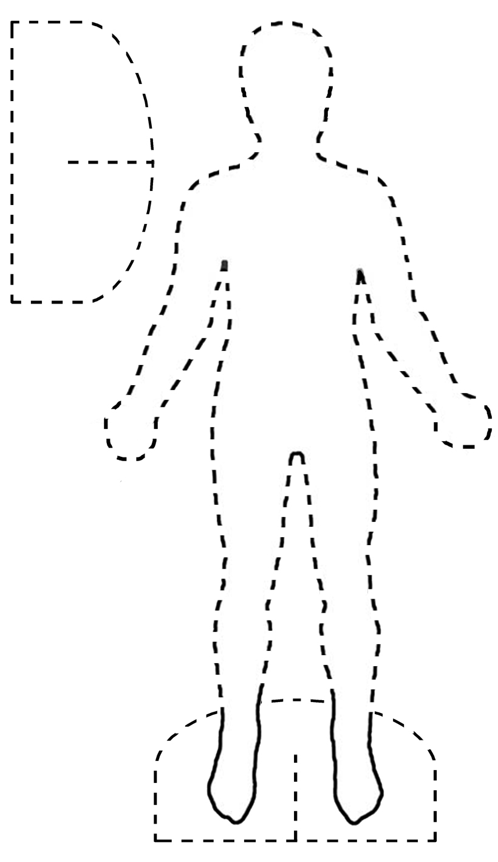
Episode 20 | 1818: Charles
Unit focus: English
Year levels: 3–6
Episode clip: Fencing
Activity 1: Character profiling
Subthemes: Character; Chores, business and employment; Language and scripting
Discover
- In this clip, we meet a variety of different characters; Charles (the youngest son of Mr Owen), John (Charles' elder brother), Sam (the former convict), Liam (the escaped convict) and Sarah (the maid). As a class, view the clip and list the characters that appear. To become familiar with their different personalities, have students select and discuss their favourite character and their least favourite character. Ask students to select a partner and, in pairs, list three characteristics of their favourite character and another three characteristics of their least favourite character. Ask each pair to share these perceptions with the rest of the class.
- Ask students to create mini-profiles of each of the characters once they are familiar with the clip. Refer students to Student Activity Sheet E20.1 Character profiling. A mini-profile is a summary of various features of a character and includes the following characteristics: physical appearance, the work they are required to perform, their age and gender, the language they use and the manner in which they speak.
- Using their mini-profiles as the basis of the students' research, conduct a hot seat role-play where each student elects to be one of the characters in the hot seat. The rest of the class questions them about their life and beliefs. The student then answers these questions while in character. Ensure that students respond using the appropriate language (eg slang if being Sam), tone (eg bossy, if being John), words and accent, if possible.
Reflect
- Ask students to imagine they are one of the characters in the clip. Have them write a short letter to a friend in England, or a diary entry, in which they describe the farm, how they feel about living and/or working on the farm, their opinion of the other characters on the farm and also a list of the work they do. As with the role-play, the students should aim to write in the style of the character, using the language, tone, style and words most suitable for their chosen character.
Download
Student Activity Sheet E20.1: Character profiling

Student Activity Sheet E20.1 |  | Episode 20 | 1818: Charles
Activity 1: Character profiling |  | Clip: Fencing
Character profiling
- Who's who: Complete the mini-profiles for each of the characters in Episode 20 | 1818: Charles. Describe their, physical appearance (eg clothing, hair and face), the task they are doing (eg building a fence), their age and position in society (eg John says 'I'm the oldest'), and their likes and dislikes. Use the template below for each character.

Character's name:________________________________

Age: Gender:

_______________________________________________
Physical appearance:

_______________________________________________
Social status:

Costume:

Action (task the character does)

Likes:

Dislikes:
- Write down two adjectives that describe the way each character speaks (eg. crossly; with an English accent; with a broad Australian accent).
Character | Adjective 1 | Adjective 2
Charles:
John:
Liam:
Sam:
Sarah:
- Imagine you are one of the characters in the clip. Write a short letter to a friend in England, or a diary entry, in which you describe the farm, how you feel about living and/or working on the farm, your opinion of the other characters on the farm and also a list of the work you do. Try and write in the style of your chosen character, using the language, tone, style and words most suitable to them.
Date________________
Dear

Yours sincerely,

Episode clip: Fencing
Activity 2: Workers' roles
Subthemes: Chores, business and employment; Language and scripting; Social order and education
Discover
- In this clip, we are introduced to the world of work on a farm.
As a class, make a list of the different jobs that the workmen are doing in this clip. Ask students to list and describe three types of work the workmen are performing and five adjectives to describe the work the men do. Review the clip and ask the students to focus on the lack of complex technologies that the farm uses, for example, machinery and equipment. Ask students how this lack of complex technology might impact on the work the men have to do in this time (1818).
- As a class, view the entire episode. Ask students to compare the physical appearance of the workers with that of their boss; Charles' father, Mr. Owen. Ask students the following question:
- Why is Mr Owen so much better dressed and well groomed than the workmen?
- Discuss the idea of the farm labourers being convicts.
- If available, read an extract from chapter 18, '1818', of the picture book My Place by Nadia Wheatley and Donna Rawlins. It starts with 'Father is mostly in Sydney…, but I want to be a farmer'. Ask the students to explore how the author wants the readers to visually interpret where Charles and his family live. Ask students to compare their visual interpretation from reading the passage with how the episode represents the life of Charles and his family.
- The only female character in the clip who works for the family is Sarah. In small groups, ask students to list the type of chores (work) she does for the family. Ask them to evaluate why Sarah doesn't do any of the labouring work. Ask students to consider the work of women today. As a class discussion, have students evaluate how attitudes to women in the workforce have changed since 1818. Have students note that Sarah does not talk, nor is she spoken to, in the clip. Ask students for an explanation and their opinion about Sarah's silence.
- Although Charles and John are children, they are helping the men with the work. Ask students to form pairs and have them list the types of chores that they complete at home. Then have them compare these with the chores Charles and John have to do on the farm.
Reflect
- Ask students to compare the chores of children in 1818 compared to today. They should particularly note the work of John and Charles. This comparison can be displayed in a Venn diagram.
- John's and Charles' lives on the farm are difficult because most chores were completed with simple implements, and by hand. Ask students to research what machinery and technologies farmers use today to assist them with their work. Once again, this comparison can be illustrated by a Venn diagram.
Download
Student Activity Sheet E20.2: Workers' roles
Aligned resources
Wheatley, Nadia, Rawlins, Donna (ill.) 2008, My Place, Walker Books Australia Pty Ltd, Sydney
Useful resources from Education Services Australia
R11073 Logging in 19th- and 20th-century Australia
R11074 Growing wheat in 19th- and 20th-century Australia

Student Activity Sheet E20.2 |  | Episode 20 | 1818: Charles
Activity 2: Workers’ roles |  | Clip: Fencing
Workers' roles
In the clip, Fencing, we see how hard life on a farm was in 1818. Answer the following questions about the clip:
- What type of work are the convict men doing on the farm?

- Write down five adjectives to describe their work.

- What work does Sarah do on the farm?

- Does she perform the same work as the men? Explain why you think this is the case.

- Why doesn't anyone talk to Sarah in this clip?

- Compare how the book, My Place, interprets where and how the Owen family lives compared to how it is portrayed in the TV series.

- Complete the table comparing your chores with those of Charles' and John's. Then, complete the Venn diagram below to show the chores of children in 1818 compared to today
Charles' and John's chores | Your chores

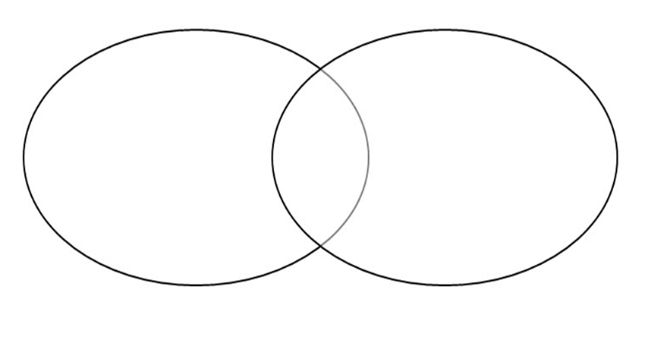
- Research what machinery and technologies farmers use today to assist them with their work. Once again, make a comparison between technologies and machines used in farming today and in the 1818s. Use the Venn diagram to organise the information.

Farming machinery used in early 1800s | Farming machinery and technologies used today

Episode clip: The convict
Activity 3: Establishing character
Subthemes: Character; Historical events
Discover
- Introduce to the class the concept of 'character development', that is, how a character is established through means of physical description, action, dialogue, interaction with other characters and background information.
- As a class, watch the previous clip, Fencing, and ask students to focus on the information they find out about the character of Liam. Ask students the following questions:
- How is Liam dressed?
- What has happened to his feet?
- What two things did he ask Charles to bring to him?
- Where was he hiding?
- Watch the clip, The convict, and draw students' attention to how the character of Liam is further developed. Ask students the following questions:
- Why is Liam a convict? What happened to him?
- Do you feel it is fair that he was convicted of his crime? Why?
- Do you believe him? Why/why not?
- What is his life's ambition?
- Ask students to create a 'Wanted' poster for Liam. Students can use the information they have gleaned from the clips to ensure they include information regarding the escaped convict's appearance, gender, age, height, accent and past. They should also consider the reward offered. This reward should reflect whether they feel Liam is a victim or a thief.
Reflect
- Ask students to write a newspaper report on an escaped convict. It can be based on Liam's story or another convict from their research on Australian history, or alternatively an imaginary convict. In the newspaper report, students must address such details as 'who, what, where, when, why and how', and include a headline, illustration with a caption, by-line (author's name), along with the name of the newspaper and date.
Download
Student Activity Sheet E20.3: Establishing character
Useful resources from Education Services Australia
R11437 'Bound for Botany Bay' – transportation of convicts to New South Wales
R10815 Convicts in Tasmania

Student Activity Sheet E20.3 |  | Episode 20 | 1818:Charles
Activity 3: Establishing character |  | Clip: The convict
Establishing character
- Answer the following questions about Liam, the Irish convict.
- How is Liam dressed?

- What has happened to his feet?

- What two things did he ask Charles to bring to him?

- Where was he hiding?

- Why is Liam a convict? What happened to him?

- Do you feel it is fair that he was convicted of this crime? Why?

- Do you believe him? Why/why not?

- What is his life's ambition?

- Create a 'Wanted' poster for Liam. Use the information you have gained from the episode or clips and include information regarding his appearance, gender, age, height, accent and past. You should also consider what reward you would offer. The reward you choose should show whether you feel Liam is a victim or a thief. Draft you ideas here.
- Write a newspaper article, reporting on an escaped convict. You can use Liam or any other escaped convict from your research on Australian history. Make sure you have a headline, a picture, a by-line (your name), and the name, issue and date of your newspaper. Also ensure that your article answers the questions of the: who, what, where, how and why.

Episode clip: The convict
Activity 4: Relationships
Subthemes: Character; Relationships; Social order and education
Discover
- As a class, discuss the development of the relationship between Charles and Liam. Ask students to identify the similarities and differences between the two characters. Students could develop a character profile for each character. Ask students to consider why Charles agreed to help Liam. Ask them to also discuss what penalty could have been enforced, in these times, if both Liam and Charles were caught by the soldiers.
- Draw students' attention to the scene in which Liam helps Charles build the fence. Focus on how the filmmakers visually reinforce the development of Charles' and Liam's friendship. Ask students to complete Student Activity Sheet E20.4 Relationships.
- Watch the episode in its entirety and ask students to comment on Charles' voice-over at the end. As a class, discuss how both characters have helped each other.
Reflect
- Ask students to imagine that they are Liam and that two years have passed since he escaped and left the farm (disguised as 'Lillian'). Have students write a letter to Charles in which they express Liam's gratitude for his assistance and inform Charles of his life since they parted company. Students should focus on the friendship that was formed and their shared dream of becoming their 'own man.'
- Explore the characters of John Owen as different from Charles Owen. As an alternate response, imagine that Liam asked John Owen to help him instead of Charles. How would the story unfold if this had happened? Ask students to rewrite the episode from the point of view of John assisting the convict.
Download
Student Activity Sheet E20.4: Relationships
Useful resources from Education Services Australia
L359 Samuel Cooper: putting the rabble to work
R10815 Convicts in Tasmania
R11437 'Bound for Botany Bay' – transportation of convicts to New South Wales

Student Activity Sheet E20.4 |  | Episode 20 | 1818:Charles
Activity 4: Relationships |  | Clip: The convict
Relationships
- Watch the clip, The convict, in which Charles helps Liam find food and shoes and Liam helps Charles build the fence. Focus on how the filmmakers highlight visually the development of Charles' and Liam's friendship. Answer the following questions.
- While Liam is telling his story of how he became a convict, what are Liam and Charles doing together?

- At what point do you think Charles begins to feel sorry for Liam?

- What does Liam say that gets Charles' attention?

- What do the two of them do, when he says this?

- What do you hear on the soundtrack?

- What do both Liam and Charles do together?

- What do you notice about how Liam and Charles are framed from the shot which shows them from behind?

- Comment on the framing of Liam and Charles when Liam is talking of his dream of having a farm and to '….be my own man'.

- What are Charles and Liam doing at the end of this scene?

- Imagine that you are Liam and two years have passed since you escaped and left the farm (disguised as 'Lillian'). Write a letter to Charles thanking him for his assistance and inform Charles of your life since you parted company. Focus on the friendship you formed and your shared dream of both becoming your 'own man'.

Date_______________
Dear

Yours sincerely,

- Explore the character of John Owen as different from Charles Owen. Imagine that Liam asked John Owen to help him instead of Charles. How would the story have unfolded if this had happened? Rewrite the clip from the point of view of John assisting the convict. The episode script can be downloaded from the Behind-the-Scenes section of My Place for Teachers website at www.myplace.edu.au

1
Episode clip: Being a lady
Activity 5: Servants and masters
Subthemes: Fashion; Gender roles and stereotypes; Social order and education
Discover
- Introduce the concepts of social class and social protocols to students. Discuss the factors which contributed to the divisions of class at this time. Ask them to consider the percentage of people who would form the three main class divisions of the era: upper class, middle class, lower class. This can be done with the aid of a pyramid diagram which shows the clear division and hierarchy of the upper classes; (such as the Owen family), followed by servants (such as Sarah the maid), ending with the convicts, Liam being a prime example.
- Look at other examples from literature which illustrate how female servants were treated by their mistresses in this era. A good example of the treatment of convicts is the Australian book by Marcus Clarke: For the term of his natural life, http://ebooks.adelaide.edu.au/c/clarke/marcus/
- Other examples of servant-master relationships can be found in stories such as Cinderella and the Grimms' Six Servants.
- Clothing is one factor that could differentiate between the classes in this era. Have students write a report on the fashions of the era by researching the clothing/fashion of the period, focusing in particular on the differences between the clothing of wealthy women and their servants. They should also list the influences on fashion at this time.
- The following websites may be useful:
- Museum Victoria http://museumvictoria.com.au
- National Gallery of Australia, Governors' Wives in Colonial Australia, http://www.nla.gov.au/pub/nlanews/2002/nov02/story-4.pdf
- National Gallery of Victoria www.ngv.vic.gov.au
- Victoria and Albert Museum www.vam.ac.uk/
- View the clip, Being a lady, and take note of the conversation between Charles and his mother in which she reveals her belief that Sarah is 'not a lady.' Ask students why Mrs Owen feels this way, and why this attitude was commonly held in 1818. Ask students to imagine how Sarah felt in overhearing Mrs. Owen reflect on her station in life.
Reflect
- Ask students to compare the clothing of Mrs Owen and Sarah. Have them imagine that they are a costume designer for this episode and do some research on what women wore in the era. Then ask students to design a costume for both Mrs Owen and for Sarah, writing an explanation for their choice of fabric, style, accessories and colours for both characters. Ask students to also illustrate their ideas for the costumes of Mrs Owen and Sarah, and perhaps find some swatches that can be included on the design.
Download
Student Activity Sheet E20.5: Servants and masters
Aligned resources
Clarke, Marcus 1874, For the term of his natural life, Marcus Clarke, 1846–1881, http://ebooks.adelaide.edu.au/c/clarke/marcus/
Grimm, Jacob and Wilhelm 1819, 'Six Servants', Grimm's Fairy Tales, Vol 2, various, Germany
Perrault, Charles, 1867, Cinderella
Museum Victoria, http://museumvictoria.com.au
National Gallery of Australia, Governors' Wives in Colonial Australia, http://www.nla.gov.au/pub/nlanews/2002/nov02/story-4.pdf
National Gallery of Victoria, www.ngv.vic.gov.au
Victoria and Albert Museum, www.vam.ac.uk/

Student Activity Sheet E14.5 |  | Episode 20 | 1818: Charles
Activity 5: Servants and masters |  | Clip: Being a lady
Servants and masters
- Do some research on the fashions/clothing worn in the early 19th century, and then write a report on the fashion of this time (1818). Focus in particular on the differences between the clothing of wealthy women and their servants. Also list the things that influenced fashion at this time. Useful websites for your research include:
- Museum Victoria, http://museumvictoria.com.au
- National Gallery of Australia, Governors' Wives in Colonial Australia, http://www.nla.gov.au/pub/nlanews/2002/nov02/story-4.pdf
- National Gallery of Victoria, www.ngv.vic.gov.au
- Victoria and Albert Museum, www.vam.ac.uk/
- View the clip, Being a lady, and take note of the conversation between Charles and his mother, in which she reveals her belief that Sarah is 'not a lady.' Why does Mrs Owen feel this way about Sarah, and why was this attitude commonly held in 1818?

- Compare the clothing of Mrs Owen and Sarah. Imagine you are a costume designer for this episode and then, using your research on what women wore in this era from the internet, design a costume for both Mrs Owen and for Sarah. Cut out a figure template for Mrs Owen and Sarah, and then place your costume on each figure. If possible, find some fabric swatches to add to your design. Answer the following questions:
- Describe the costume of Mrs Owen in the clip (make sure you include her accessories, hairstyle and make-up).

- Describe Sarah's costume in the clip.

- Imagine you are the costume designer for this episode. Write a description of how you would dress Mrs Owen. Include a labelled illustration and explain your choice of fabric, style, colours and accessories for her costume.

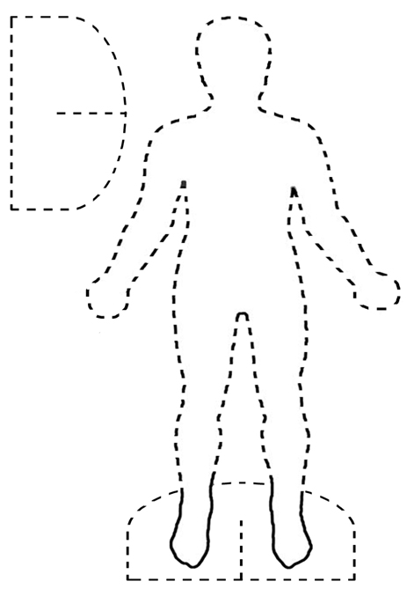
- Imagine you are the costume designer for this episode and write a description of how you would dress Sarah. Include a labelled illustration and explain your choice of fabric, style, colours and accessories for her costume.

Episode clip: Being a lady
Activity 6: Stereotyping
Subthemes: Character; Gender roles and stereotypes; Language and scripting;
Discover
- Introduce the concept of a 'stereotype' and give examples for the students to consider. For example, villains, witches and ogres from fairytales are generally considered evil, mean and 'bad', while fairies, princesses and heroes are considered helpful, kind and 'good.' Explain that stereotypes are generalisations and often a judgement on the character and actions of a person. Use the example from Shrek, that although Shrek is an ogre, he is not 'mean and nasty', and even though Princess Fiona is a princess she does not act like the stereotype of how a princess should act. As a class, have students list ten good characters and ten bad characters from literature or film.
- Ask students to focus on the conversation in which Mrs Owen stereotypes Sarah. Ask them the following questions:
- Why does Mrs Owen lend Sarah her 'second-best' shawl?
- Find the piece of dialogue that shows Mrs Owen's belief that she is better than Sarah.
- Why is Mrs Owen worried about the wedding?
- Why is Mrs Owen happy to see the soldiers?
- As a class, watch the entire episode and focus on the wedding scene. Ask students to identify in what ways Liam plays the stereotype of 'a lady'. Draw students' attention to his physical behaviour, his stance, his voice and the accent he uses. Explain that this is an example of gender stereotyping and ask students if they can think of any other contemporary examples of gender stereotyping in film and TV.
Reflect
- Ask students to create another scene in which Mrs Owen realises she has been unfair to Sarah and attempts to mend her ways by treating Sarah with respect and kindness. Have them present the scene as a storyboard in which they draw the image they wish to have in each shot, as well as writing the dialogue and any sound effects to be used.
Download
Student Activity Sheet E20.6: Stereotyping
Aligned resources
Shrek 2001 (film), Andrew Adamson and Vicky Jenson (directors), Dreamworks Animation, USA
Useful resources from Education Services Australia
L8144 Writing narratives: characters

Student Activity Sheet E20.6 |  | Episode 20 | 1818:Charles
Activity 6:Stereotyping |  | Clip: Being a lady
Stereotyping
- Answer the following questions.
- Why does Mrs Owen lend Sarah her 'second-best' shawl?

- Find the piece of dialogue that shows Mrs Owen's belief that she is better than Sarah.

- Why is Mrs Owen worried about the wedding?

- Why is Mrs Owen happy to see the soldiers?

- How does Liam behave as a 'woman' at the wedding?

- Create another scene in which Mrs Owen realises she has been unfair to Sarah and attempts to mend her ways by treating Sarah with respect and kindness. Present the scene as a storyboard. Draw the image you wish to have in each shot, write the dialogue and note any sound effects that you would use.
Setting: __________________________  Action: __________________________  ____________________________  Dialogue: ________________________  ____________________________  __________________________  __________________________ | Setting: __________________________  Action: __________________________  ____________________________  Dialogue: ________________________  ____________________________  __________________________  __________________________ | Setting: __________________________  Action: __________________________  ____________________________  Dialogue: ________________________  ____________________________  __________________________  __________________________
Setting: __________________________  Action: _________________________  ____________________________  Dialogue: ________________________  ____________________________  __________________________  __________________________ | Setting: __________________________  Action: __________________________  ____________________________  Dialogue: ________________________  ____________________________  __________________________  __________________________ | Setting: __________________________  Action: __________________________  _____________________________  Dialogue: ________________________  ____________________________  __________________________  __________________________

