Episode 5: 1968: Sofia
Unit focus: History
Year level: Years 3–6
Episode clip: Speaking the language
Activity 2: Language barriers
Subthemes: Language and scripting; Multiculturalism; Social order and education
According to the 2006 Australian Government census, the Greek community is the seventh largest ethnic group in Australia. The Greek language is the fourth most common language in Australia (after English, Chinese and Italian). Many students study another language in school or outside school hours. Some students study a language that is the native tongue of their parents.
Discover
- Ask students if they speak a language other than English at home or if they have relatives that speak another language. List these languages. Ask students if they were the first generation in their family born in Australia. If so, they would be classified as 'first generation'. If not, what generation are they?
Reflect
- Ask students to create a data chart on languages other than English spoken at home. The chart can be completed electronically or as a poster for display.
- Ask students to survey other students within the school to gather information about the languages spoken. Create a chart of information gathered about the whole school cohort.
- Ask students to determine which cultures form the make-up of the school.
Download
- Student Activity Sheet H5.2: Languages other than English
Episode 8: 1938: Colum
Unit focus: History
Year level: Years 3–6
Episode clip: The dole inspector
Activity 1: Hard times
Subthemes: Chores, business and employment; Historical events; Social order and education
Discover
- What did the Great Depression really mean in Australia? Refer to the 'Decade timeline' for descriptions of the 1930s. Read about the effects of the Great Depression on families and individuals.
- The dole inspector is portrayed as a much feared character, and the community work together to defy the inspector so they can sell market produce grown in their backyard to make money to survive.
Reflect
- Students view the clip, 'The dole inspector' and create a class poster, or mind map, of characteristics and facts that visually represent a community experiencing unemployment and economic hardship. Use examples of clothing, food, housing and communities.
- Students research the beginnings of the economic crisis that became the Great Depression in 1930s Australia. Information gathered should include the following key research items:
- jobs
- unemployment
- housing
- the dole
- recollections of experiences.
- As an added experience, research groups can view excerpts from the documentary series, The Bridge (55 mins), which is the first episode of the three-part series entitled 'Constructing Australia'. The film is available at Screen Australia, http://www.screenaustralia.gov.au/learning/constructingaustralia
- Other helpful websites include:
- Seniors.com.au, http://www.seniors.gov.au
- History.org, 'History: The Great Depression', http://www.australianhistory.org/great-depression.php
- Screen Australia Digital Learning, http://dl.screenaustralia.gov.au
- Students, working in small groups, can present the information they find as a front page story for a newspaper on the topic 'Tips for surviving the Great Depression'. The information can be set out with major headlines, diagrams, old footage pictures gathered from various websites and articles relating to the Great Depression in Australia.
Download
- Student Activity Sheet H8.1: The Great Depression
Activity 2: Individual strength
Subthemes: Chores, business and employment; Historical events;
Social order and education
Many inspirational stories came out of Australia during the Great Depression. In times of hardship, communities came together to help each other. This support and charity is depicted in Episode 8 of My Place, with Colum, his family and friends.
Discover
- Research and examine some inspirational stories of the Great Depression. Discuss why optimism is so important in times of hardship, and encourage students to make the connections to their own community.
Reflect
- Students watch the following clips from the Screen Australia Digital Learning website and take notes about what they see and hear, so they are ready for discussion on the inspirational stories.
- The Prime Minister's National Treasures, 'James Scullin and the GCMG', http://dl.screenaustralia.gov.au/module/1095
- The Bridge, 'The Bridge Workers', http://dl.screenaustralia.gov.au/module/873
- 'Australia Today – Men of Tomorrow', http://australianscreen.com.au/titles/australia-today-men-tomorrow/clip1
- Students share their thoughts on the clips and draw comparisons on their own community experiences. Tough economic times also affect the lives of students today. Use Student Activity Sheet H8.2 to encourage students to brainstorm their thoughts on how people cope with tough times, both past and present.
Download
- Student Activity Sheet H8.2: Coping with hard times
Activity 3: Susso
Subthemes: Chores, business and employment; Historical events; Social order and education
Discover
- Many people were homeless and relied on relief schemes and food tickets to keep themselves alive. Farmers struggled, unable to pay back loans. Soup kitchens and 'tent cities' sprung up in many cities and towns.
- A form of unemployment benefits was introduced known as the 'susso', which was an abbreviation for sustenance, but its recipients felt a sense of undeserved shame. Long dole queues were found across the land. Many families who lost their homes moved to tent city towns, such as Happy Valley in the council of Waverley in New South Wales. The Unemployment Relief Works Program built valuable roads, pools and buildings giving hundreds of people employment and a sense of self-worth
- Ask students to discuss the question: Should government unemployment benefits still exist?
Reflect
- Students conduct a debate: 'For or against the dole.'
- The students are divided into groups of five and given a 'for' or 'against' tag. Ask them to work in their teams to research information on the current unemployment benefits scheme and investigate points for or against it. There may be two teams for it and two teams against it. Each team should be given the opportunity to debate in a formal or informal debate setting.
Download
- Student Activity Sheet H8.3: Unemployment relief
Episode 9: 1928: Bridie
Unit focus: History
Year level: Years 3–6
Episode clip: Children's chores
Activity 2: Work
Subthemes: Chores, business and employment; Entertainment and games; Social order and education
Times were tough in 1928. The economy was on the brink of depression, and soon Australia would see job losses and a housing crisis. Children were given a lot of responsibility and in many cases had little or no time for play. Episode 9 highlights the quest of the children to escape their daily routine in order to have some fun.
Discover
- 'Historyface' and blog: Using the 'historyface' template students are asked to create a profile for a child in 1928, and add a blog attachment. The blog may include a diary entry, or a list of complaints relating to tough times and chores. Students are encouraged to become the voice of their child character of 1928.
Download
- Student Activity Sheet H9.2: A child in 1928
Activity 3: Heritage
Subthemes: Multiculturalism; Social order and education
Bridie's mother is Irish. In the early 1900s, the Irish constituted a large proportion of immigrants to Australia. Most Irish immigrants came to the colonies on assisted passage after escaping the crippling effects of the 1840s Irish Potato Famine. Find out more about the legacy of the Irish in Australia at:
- Museum Victoria: Origins, 'History of immigration from Ireland', http://museumvictoria.com.au/origins/history.aspx?pid=30
- Racism. No Way, http://www.racismnoway.com.au/classroom/factsheets/57.html
Discover
- Discuss the countries of origin of students' families. Collect data on the different cultures represented in the class and record this as a graph.
Reflect
- Ask students to interview a senior member of their family and ask them questions about their own parents and grandparents. Students then document and chart a genealogical tree of their ancestors as far back as they can research.
Download
- Student Activity Sheet H9.3: Your family tree
Episode 11: 1908: Evelyn
Unit focus: History
Year level: Years 3–6
Episode clip: Mr Wong's Emporium
Activity 4: Multicultural Australia
Subthemes: Multiculturalism; Politics; Social order and education
In the early years of the twentieth century, at the time of the Federation of the colonial states and territories, many important events occurred in Australia. These include:
- the implementation of laws to improve working conditions and devise fairer wages
- the extension of the vote to non-Indigenous women
- the introduction of the White Australia policy, which restricted immigration.
The new Australian Constitution discriminated against Indigenous Australians by excluding them from the national census and preventing parliament from making laws about them.
At the time of Federation in 1901, three quarters of the population were Australian born, the majority of English, Scottish and Irish descent. The Chinese, who had represented 3.3% of the population in 1861, represented 0.8% of the population at the time of Federation.
Discover
- Students can research why and when Chinese people came to Australia. Mr Wong is a significant character in this episode and his story could be a good starting point for discussing the reasons Chinese people came to Australia at different times. Why might Mr Wong have come to live in Australia?
Reflect
- As a class, look at the laws and policies of Australia that have had an impact on Chinese Australians. How might Mr Wong have been affected by Australian laws and policies?
- Students could develop a timeline of Chinese migration to Australia. The timeline should use dates, images and reasons for coming to Australia.
Download
- Student Activity Sheet H11.4: Timeline of Chinese immigration
Episode 12: 1898: Rowley
Unit focus: History
Year level: Year 3–6
Episode clip: 1,000 good deeds
Activity 1: School in the 1800s
Subtheme: Social order and education
Many children in the 1800s lived a life of hardship, particularly if they came from a family dependent on paid jobs within the economy. Class status affected opportunities for a good education and the chance to enjoy a carefree childhood. School rooms were very different to the classrooms of today. Schooling for children like Rowley was limited to primary school.
Discover
- In pairs, students research the availability education and resources for children in the late 1800s. Students can research educational facilities, educational values and expectations, rules and regulations, uniforms, buildings, and general information about schools during that era. Did all children get a fair go?
- Use the following websites as a starting point:
- History Australia, 'The Evolution of Education in Australia', http://www.historyaustralia.org.au/ifhaa/schools/evelutio.htm
- '"New South Wales Pioneers", Photographs by George Bell 1890–1900' at Powerhouse Museum, http://www.powerhousemuseum.com/pdf/OPAC/246256.pdf
(There is a photo of two children riding to school on page 9.)
Reflect
- Students can create a virtual classroom of the era, including notes and information from their research. Students could elect to design the classroom using illustrations on paper or an image-editing software program. Kahootz 3 is an ideal 3-D animation software program to use here. The software is available for purchase from the Australian Children's Television Foundation (ACTF) website at http://www.kahootz.com
- Visit ABC3, 'My Place', http://www.abc.net.au/abc3/myplace and select '1898' to see how a web designer has created a model of Rowley's bedroom and kitchen.
Episode clip: Founding the ALP
Activity 7: The ALP
Subthemes: Politics; Social order and education
Discover
- As a class discuss the question: Why was the Australian Labor Party (ALP) formed and who were the founders trying to help?
Reflect
- Hot seat role-play is a strategy where students research and analyse a character from the episode. Through their observations they find out who the person is, their importance to the story and what differentiates them from other characters. Once students understand the character, they can pretend to be them and answer questions from other members of the class while remaining in character.
- Students choose a character from the episode. In small groups, students can develop a storyline for their character, creating a drama in which the character interacts with other characters based on a given scenario.
- Each scenario listed below relates to the hard times experienced by workers in the 1890s.
- Brickworks employee gets ill and faces his boss about the situation. He gathers others who are ill to support his case.
- Local publican hosts secret meetings for the unemployed brickworks employees at the back of his pub.
- Unemployed workers have a meeting to discuss the problems they face. Some of them agree that they should join the ALP and others feel scared.
- Bosses and company owners talk about not paying out money to ill workers. They are faced with having to deal with locals getting together for secret ALP meetings.
Download
- Student Activity Sheet H12.5: Hot seat role-play
Episode clip: Workers' rights
Activity 8: Family values
Subthemes: Politics; Social order and education
A woman's role in the late 1800s was restricted. It was expected that she maintain the home and family while the husband/father went out to work. However, in many poor families the woman had to work to earn money, especially when men lost their jobs.
Discover
- Research and discuss women's roles in History. Ask students to utilise the following websites to locate stories and pictures of women of the era:
- National Library of Australia, 'Picture Australia: Picture Trails: Society', http://www.pictureaustralia.org/trails/society.html
- ABC, 'Australian Suffragettes', http://www.abc.net.au/ola/citizen/women/women-home-vote.htm
Reflect
- Students can create an imaginary 'historyface' profile (based on something similar to a Facebook page) for a female suffragette from the 1800s. Information can include a profile picture, status update, education, family background, likes and dislikes and groups she may be linked with. Student Activity Sheet H12.6 contains a 'historyface' template that can be used for this activity. Make sure that students answer the questions:
- Who is she?
- What groups and causes does she stand for?
- What is her status?
Download
- Student Activity Sheet H12.6: Suffragette profile
Episode 13: 1888: Victoria
Unit focus: History
Year level: Year 3–6
Activity 5: Manners and manors
Subtheme: Social order and education
The Owen family and Victoria's family appear to live the same life, but what may lie within vastly different. Their houses and family dynamics are different. Discuss these differences and come up with a Social Status Ladder depicting the social expectations of people living in 1888.
Discover
- Who is at the top of the social status ladder in 1888, and who is at the bottom? Provide reasons why this was the case. Once you have created a social status list, ask students to list the expectations of children for each of the rungs on the social status ladder, including manners, dress code, education and chores. See Sovereign Hill Education, http://sheducationcom.ascetinteractive.biz/?id=teachers
Reflect
- Create a Social Status Pyramid. This is a visual representation that students use to depict the social divide in Australia in 1888 based on information from your discussion.
Download
- Student Activity Sheet H13.6: Social pyramids
Activity 6: Food for thought
Subthemes: Food; Social order and education
Self-sufficiency is depicted in the story of Victoria's family through the freehold they maintain in their backyard. What they grew and nurtured is what they ate.
Discover
- 'What is in their garden and what is in your garden?' A comparative look at the type of food available in 1888 and in present times. Discuss the contents of Victoria's family garden. Using an A3 sheet of paper divided into four parts labelled:
- Garden
- Store bought
- Livestock
- Other.
- Ask students to write the type of food grown, commodities available for purchase, livestock kept in residential areas and other items necessary for life in 1888.
- Make a similar poster to depict where and how students obtain their food today.
Reflect
- 'What are the obvious differences in food origins and food consumption between the two eras?'
Download
- Student Activity Sheet H13.7: Where does food come from

Student Activity Sheet H5.2 |  | Episode 5: 1968: Sofia
Activity 2: Language barriers |  | Clip: Speaking the language

Languages other than English
Investigate which languages other than English (LOTE) are spoken by your classmates. Do their parents also speak languages other than English at home?
Collect the data on the chart and then add your information to a data chartor graph.
Data chart: classmates
Student's name | Generation Australian | LOTE spoken | LOTE spoken by parent 1 | LOTE spoken by parent 2
Data chart: school mates
Student's name | Generation Australian | LOTE spoken | LOTE spoken by parent 1 | LOTE spoken by parent 2

Student Activity Sheet H8.1 |  | Episode 8: 1938: Colum
Activity 1: Hard times |  | Clip: The dole inspector
The Great Depression
- The Great Depression was a worldwide economic crisis that affected Australians in many ways. Research the factors that shaped this economic crisis in Australia in the 1930s (who, what, where, when, how). The information you gather on the Great Depression should include the following key areas:
- unemployment and low wages
- 'susso' and charity
- housing crisis and the homeless
- key figures and personal recounts of experiences
Some helpful websites include:
- seniors.com.au, http://www.seniors.gov.au
- History.org, http://www.australianhistory.org/great-depression.php
- Screen Australia Digital Learning, http://dl.screenaustralia.gov.au
- Present your research as a newspaper article written by a journalist either: interviewing a homeless person and reporting their personal story, or as a documentary on the Great Depression. The information can be set out with major headlines, diagrams, original images gathered from various websites and articles relating to the Great Depression in Australia.
- You can create an online or paper version of your newspaper story. Use your local or state newspaper websites as a guide to formatting your own newspaper page.
- Develop some layout ideas below.

Student Activity Sheet H8.2 |  | Episode 8: 1938: Colum
Activity 2: Individual strength |  | Clip: The dole inspector

Coping with hard times
- View the clips and excerpts from the three Screen Australia Digital Learning websites: The Prime Minister's national treasures, The Bridge, and Men of Tomorrow.
- Take notes about how the people depicted in the clips cope with hard times.
- Complete the Venn diagram below by listing the ways people survived tough times in the 1930s, and then list some ways people in need cope today.
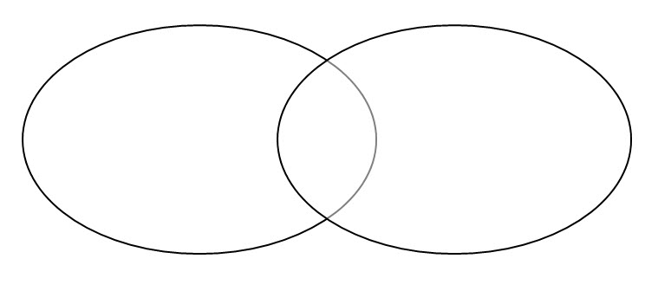
Tough economic times
of the 1930s

Similarities

Tough economic times
of today

Student Activity Sheet H8.3 |  | Episode 8: 1938: Colum
Activity 3: Susso |  | Clip: The dole inspector
Unemployment relief
- Research the history of Australia's unemployment relief scheme. Note when it started, why it started, who started it and how it operates (past and present). List any additional information on the topic.

- Develop five points for your argument, for or against the unemployment relief scheme.

Student Activity Sheet H9.2 |  | Episode 9: 1928: Bridie
Activity 2: Work |  | Clip: Children's chores
A child in 1928
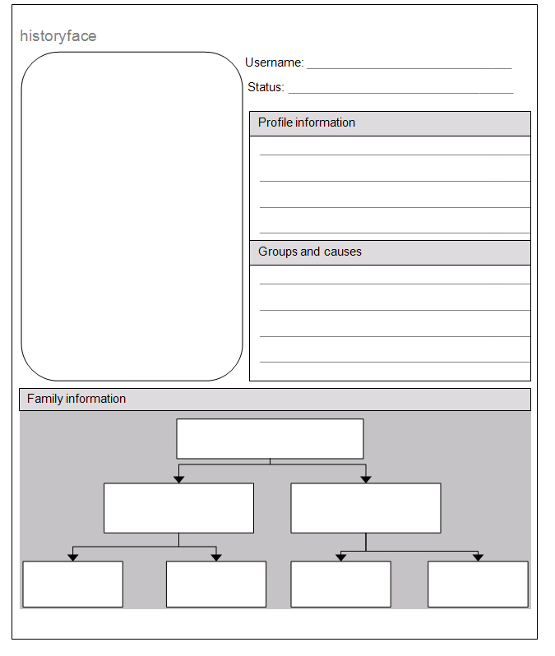

Student Activity Sheet H9.2 |  | Episode 9: 1928: Bridie
Activity 2: Work |  | Clip: Children's chores

Your blog
Write a recount-style diary entry in the form of a blog. You are writing from the point of view of a child in 1928. You must include a recollection of the events and your thoughts and feelings during a day in your life.
A blog
A blog is an informal piece of writing and a place where you can express thoughts and feelings freely. You can write very honestly and openly about your day as a child in 1928. Check out some blogs on your local news website.
Blog tips
Be honest and speak your mind about a topic or event from the day. Write as if you are a child in 1928. Write about chores, parents and your general opinion of it all.

Student Activity Sheet H9.3 |  | Episode 9: 1928: Bridie
Activity 3: Heritage |  | Clip: Children's chores
Your family tree
- Use the template below as a model to create a family tree. Create the family tree in a digital format or redraw the diagram onto a poster.
- Add the names of your family members, beginning with the oldest known relatives at the top and continuing with other family members in each box below.
- You can also add photographs to your family tree by inserting a picture from a digital file or by printing and pasting them onto the poster.
- Ask an older family member to help you with your family tree. This is an ideal way to find out the names of those relatives you have never met!

Your family tree name
Great-grandparents
Great-grandparents
Grandparents
Grandparents
Grandparents
Grandparents

Student Activity Sheet H11.4 |  | Episode 11: 1908: Evelyn
Activity 4: Multicultural Australia |  | Clip: Mr Wong's Emporium

Timeline of Chinese immigration
- Investigate why, when and how Chinese people first came to Australia.
- Record this on a timeline and add in the dates of Chinese immigration that followed.
- Locate Mr Wong on the timeline.
- Use the style in the timeline example below or create your own version.
Date
Date
Date
Date
Date

Student Activity Sheet H12.5 |  | Episode 12: 1898: Rowley
Activity 7: The ALP |  | Clip: Founding the ALP
Hot seat role-play
- Below you will find scenarios adapted from scenes in this episode. Choose one of the scenarios and identify with one of the characters. You will need to understand who your character is and why he or she is in that situation.
- You will then be asked to answer questions about your character and your situation in the scenario. Have fun in the hot seat!
- Scenario 1
Brickworks employee gets ill and faces his boss about the situation. He gathers others who are ill to support his case.
- Scenario 2
Local publican hosts secret meetings for the unemployed brickworks employees at the back of his pub.
- Scenario 3
Unemployed workers have a meeting to discuss the problems they face. Some of them agree that they should join the ALP and others feel scared.
- Scenario 4
Bosses and company owners talk about not paying out money to ill workers. They are faced with having to deal with locals getting together for secret ALP meetings.
- Prepare some notes about your character below.

Student Activity Sheet H12.6 |  | Episode 12: 1898: Rowley
Activity 8: Family values |  | Clip: Workers' rights
Suffragette profile

Student Activity Sheet H13.6 |  | Episode 13: 1888: Victoria
Activity 5: Manners and manors |  | Clip 2: Victoria's family supper
Social pyramids
Social status pyramid of Australia in 1888: Fill in the pyramid with information and pictures of the types of people you feel would relate to a particular social class.

Student Activity Sheet H13.7 |  | Episode 13: 1888: Victoria
Activity 6: Food for thought |  | Clip 2: Victoria's family supper
Where does food come from?
What are the commonalities and differences between food origins of 1888
and 2010?
Food origins | Commonalities: 1888–2010 | Differences: 1888–2010
Garden
Store bought
Livestock
Other commodities

Student Activity Sheet H12.5 |  | Episode 12: 1898: Rowley
Activity 7: The ALP |  | Clip: Founding the ALP
Hot seat role-play
- Below you will find scenarios adapted from scenes in this episode. Choose one of the scenarios and identify with one of the characters. You will need to understand who your character is and why he or she is in that situation.
- You will then be asked to answer questions about your character and your situation in the scenario. Have fun in the hot seat!
- Scenario 1
Brickworks employee gets ill and faces his boss about the situation. He gathers others who are ill to support his case.
- Scenario 2
Local publican hosts secret meetings for the unemployed brickworks employees at the back of his pub.
- Scenario 3
Unemployed workers have a meeting to discuss the problems they face. Some of them agree that they should join the ALP and others feel scared.
- Scenario 4
Bosses and company owners talk about not paying out money to ill workers. They are faced with having to deal with locals getting together for secret ALP meetings.
- Prepare some notes about your character below.

Student Activity Sheet H12.6 |  | Episode 12: 1898: Rowley
Activity 8: Family values |  | Clip: Workers' rights
Suffragette profile

