Episode 1: 2008: Laura
Unit focus: History
Year level: Years 3–6
Episode clip: The apology
Activity 1: The Stolen Generations
Subthemes: Culture; Historical events; Indigenous perspectives
Discover
- Ask students to discuss the following questions:
- What are the Stolen Generations?
- Why is the apology significant in History?
- Refer to Follow the Rabbit-Proof Fence by Doris Pilkington Garimara. Students can also view the clip from the feature film at australianscreen, 'Rabbit-Proof Fence (2002)', http://aso.gov.au/titles/features/rabbit-proof-fence/clip1
[Please note that the clip from Rabbit-Proof Fence is rated PG (parental guidance) and permission should be gained from parents and the school principal before viewing. It is recommended that teachers view all film content before introducing it to students to ensure that it is appropriate for the class.]
- As a class, review the following websites and the information contained within them about the Stolen Generations:
- Australian Human Rights Commission, http://www.hreoc.gov.au
- ——'Bringing them home: The "Stolen Children" report (1997)' http://www.hreoc.gov.au/social_justice/bth_report/index.html
- ——'Bringing them home education module' http://www.hreoc.gov.au/education/bth/index.html
- ReconciliACTION Network, http://reconciliaction.org.au
- If possible, invite a local Indigenous Elder to the school to talk about reconciliation.
- Ask students to create a graphic organisational chart (a KWL Chart) about the Stolen Generations. A KWL Chart enables students to classify information based on prior knowledge. It will help students to organise information as they gather it and disseminate the data at the end of their research. The three basic areas of classification are:
- What I Know
- What I Want to know
- What I Learned.
Reflect
- Ask students to research personal accounts of Indigenous people who are part of the Stolen Generations. Collect their stories in an anthology to be displayed and read on National Sorry Day.
- Visit the National Sorry Day Committee on the website below:
http://www.nsdc.org.au
Download
- Student Activity sheet H1.1: Indigenous issues
Activity 2: Remembering
Subthemes: Culture; Indigenous perspectives; Politics
In this clip, Laura looks at the faces of family and friends watching the apology at the local community centre and observes their reactions. The expressions on the faces of people in the clip demonstrate strong feelings about it. These facial expressions and gestures are emotional signposts.
Discover
- Ask students to brainstorm ideas on how both Laura and Aunty Bev are affected by the apology. Student responses can be mapped out on a class poster.
Reflection
- Ask students to write what they believe are the thoughts of Laura or Aunty Bev about the apology.
- Construct a hot seat role-play where students take on the role of significant people in the apology. For example, it could be Kevin Rudd, or an Indigenous person in parliament. Students stay in role and answer questions from the class about how they perceived the significance of the apology.
Download
- Student Activity Sheet H1.2: Investigating loss
Activity 3: Government policy
Subthemes: Culture; Indigenous perspectives
The removal of Aboriginal and Torres Strait Islander children from their parents was the accepted practice of state and federal governments. In 1997, the Bringing them home report focused on the practices of government from 1910–1970. On 13 February 2008, Prime Minister Kevin Rudd apologised for the pain caused by decades of state-sponsored mistreatment of Indigenous Australians and the continuing impact on Australian society.
Discover
- Ask students to research government policies that had a negative impact on Indigenous people. This information can be merged into a timeline to plot significant events affecting Indigenous rights in Australia.
- As a class discuss the significance of events leading up to the apology.
- Ask students to research stories and statements in newspapers and magazines from Indigenous people following the apology. Refer to the teachers' notes, activities and worksheets on the website below.
- Australian Human Rights Commission, http://www.hreoc.gov.au
- ——'Bringing them home, education module',
http://www.humanrights.gov.au/education/bth/index.html
- ——'Bringing them home Community Guide 2007',
http://www.humanrights.gov.au/education/bth/community_guide/index.html
Reflect
- Share the stories with the class. They can be presented as short essays, or pictorial stories.
Download
- Student Activity Sheet H1.3: Government practice
Activity 4: Symbolism
Subthemes: Culture; Historical events; Indigenous perspectives
Discover
- In the clip, the Aboriginal flag plays a major role, but people also have beads, necklaces, ribbons and arm bands displaying the colours of red, yellow and black. Many Aboriginal people identify with these colours. Research the designer of the flag, Harold Thomas, and collect information on his background.
Reflect
- As a class, research and discuss the symbolic significance of the colour and shape on the Aboriginal Flag. Ask students to find out where the flag originated and what the design means. Refer to the Australian Institute of Aboriginal and Torres strait Islander Studies (AIATSIS), http://www.aiatsis.gov.au/fastfacts/AboriginalFlag.html
- As an extension activity, students could also investigate the meaning and significance of the Torres Strait Islander flag.
Download
- Student Activity Sheet H1.4: Symbols of unity
Episode 2: 1998: Mohammed
Unit focus: History
Year level: Years 3–6
Episode clip: Discrimination
Activity 1: Cricket
Subthemes: Culture; Entertainment and games; Historical events
The history of the game of cricket is not clear-cut. Some believe it originated as a children's game in Medieval times. There are references to an early game played in pastures in Kent, England, where short grass made it possible to bowl or roll a ball of rags or wool at a wicket-gate target. A 'bat' was formed from a shepherd's crook, or staff.
Discover
- Ask students to research the possible origins of cricket. They should develop ten fact cards that answer the following questions:
- Where and when was the first recorded cricket match?
- Who was involved in playing this early game?
- How was the game played?
- What were the rules?
- How did the game develop after this time?
- When and by whom were the first 'Laws of Cricket' established?
- When and where was the first international game of cricket played?
- Where is cricket played today?
- Who are the most noted players today?
- Describe the differences in the way women and men play the game.
Reflect
- Ask students to create a KWL chart about the history of cricket. A KWL chart is a graphic organiser that enables students to classify information. It will help them to organise material as it is gathered during their research. The three basic areas of classification in the chart are:
- What I Know
- What I Want to know
- What I Learned
- The following websites are a useful resource for this activity:
- Cricket Australia, http://cricket.com.au
- Melbourne Cricket Ground, www.mcg.org.au
Download
- Student Activity Sheet H2.1: KWL chart: history of cricket
Activity 2: Australian cricket
Subthemes: Culture; Entertainment and games; Historical events
The sport of cricket is embedded in Australian culture owing to our British heritage. In this episode Mohammed is infatuated by cricket, but his father isn't keen on it. He believes it's not a game for 'wogs', that it is the preserve of 'Australians'.
An interesting event in Australian cricketing history is that 14 Indigenous players toured England in 1868 to showcase their skills. The team performed well on the long tour, playing 47 games of which they won 14 and drew 19. This was the first organised group of Australian cricketers to travel overseas.
Discover
- Ask students to consider how the game of cricket became so popular and widespread in Australia, where many believe that Australian cricket is the best in the world. Have students develop a questionnaire about the popularity of cricket, which they can then put to other students, teachers and parents. Ask them to collate the results and prepare a report on popular opinion in their community about cricket in Australia.
- Divide the class into small groups, assign them an era in History, eg 1851–1910 or 1911–1939, and ask them to research the contribution of Indigenous cricketers during this period. Each group could produce a poster with images of the cricketers and information about their achievements.
Reflect
- Ask students to research an aspect of Australian cricket. For example, they might write a report about their favourite team, player or coach. This information can be presented in a digital slideshow format or as a poster. Alternatively, ask the students to create an advertisement for publicising the wonders of Australian cricket to the rest of the world. The advertisement could be for a magazine or for television.
Download
- Student Activity Sheet H2.2: Indigenous Australian cricketers
Activity 3: Equality in sport
Subthemes: Culture; Entertainment and games; Gender roles and stereotypes
In Episode 2, Mohammed and Danielle discuss the school cricket tryouts. Danielle is passionate about wanting equality in team selection and voices her opinion about discrimination against girls who want to play in the school cricket team.
Discover
- Ask students to discuss gender equality in sports played at their school. They could record their responses to the following questions on a poster in the classroom:
- Are there teams for both girls and boys for every sport played at the school?
- Does the school offer mixed teams for sports?
- Do girls often try out for so-called 'boys' teams'?
- Have gender roles changed in sports at schools in the last ten years?
- Divide the class into small groups. Each group should research, and present, a report on one of the following teams:
- The Australian women's cricket team
- The Australian women's basketball team
- The Australian women's soccer team
- The Australian women's baseball team
- The Australian women's water polo team
- The Australian women's netball team
- The Australian women's volleyball team
- The Australian women's hockey team
- The Australian women's Rugby Union team
- The Australian women's Rugby League team
- Ask students to view the clip on Screen Australia digital learning, Women and sport in Australia, http://dl.screenaustralia.gov.au/module/1494/#about
- There is a range other information on the topic on The Australian Women's Register, http://www.womenaustralia.info
Reflect
- Student Activity Sheet H2.3 contains a Spider Map, which has headings that will assist students to organise their responses to the video clip.
Download
- Student Activity Sheet H2.3: Australian women in sport
Episode clip: Ramadan
Activity 4: Culture clash
Subthemes: Beliefs; Culture
Ramadan falls on the ninth month of the Islamic lunar calendar. During this holy month, Muslims focus on spiritual purification through self-sacrifice, prayer and by fasting from sun-up to sundown. Refer to the following SBS website: World News Australia, http://www.sbs.com.au/news/article/1075597/Muslims-gear-up-for-Ramadan
Discover
- Ask students to research the significance of Ramadan. The websites below are suitable as teacher references. Discuss the position of Ramadan in Australian culture. Consider how the requirements of Ramadan might affect its followers' ability to participate in everyday activities.
- Ramadan Awareness Campaign, http://www.ramadan.com.au
- University of Melbourne: University Library Digital Repository, 'Muslim Australians: Their Beliefs, Practices and Institutions by Professor Abdullah Saeed 2004', http://dtl.unimelb.edu.au
- Asia Education Foundation: http://www.asiaeducation.edu.au/default.asp
Reflect
- Ask students to record their discoveries about Ramadan. Use Student Activity Sheet H2.4 to write information on the 'Describing wheel'. A describing wheel is a graphic organiser that encourages students to describe facts and ideas relating to a topic. The wheel has a place for the topic in the centre, surrounded by spokes in which students can record facts and ideas.
- Invite a spokesperson from the Islamic community to speak about how Ramadan is observed in Australia.
Download
- Student Activity Sheet H2.4: Ramadan facts
Activity 5: Fasting
Subthemes: Culture; Customs and traditions; Food
Fasting is an important part of religious observances during the month of Ramadan. Participants eat before the sun comes up and after it goes down for an entire month. Families must prepare special foods that will sustain them throughout the day.
Discover
- Encourage students to find out more about the special foods prepared for Ramadan. Ask them to research recipes and list the ingredients. Find the origin of any unknown ingredients and if they are used by any other cultures for special occasions.
- Discuss 'fasting' and its effects on people, particularly young people. Ask the class if they know of other religions and cultures that observe fasting.
- List other Islamic customs. Some suggestions could be women wearing a veil, pilgrimages to Mecca, and praying rituals. Compare these with practices from other cultures.
Reflect
- Ask students to respond to the following focus questions:
- What types of foods are eaten during Ramadan?
- Who prepares the food for Ramadan?
- Why are there restrictions on the times food can be eaten?
- When can people break their fast? (This question relates to Mohammed's grandmother asking whether he will be able to eat before his cricket tryouts.)
- How do families celebrate the end of Ramadan?
- Students share their findings in an oral presentation to the class.
Download
- Student Activity Sheet H2.5: Fasting during Ramadan
Episode clip: The ball of the century
Activity 6: Warnie
Subthemes: Culture; Entertainment and games; Historical events
There are many great moments in Australia's sporting history, but few as memorable as Shane Warne's performance in the 1993 Ashes series. Many believed he was the best leg-spin bowler in the world and his performances resulted in a resurgence in the popularity of cricket.
Ask students to find and view videos of the 1993 Ashes tour online, using links found at 'Google videos'.
Discover
- Ask students to collect information about the cricketing achievements of Shane Warne. Record this information on date/event fact cards and use them to develop a timeline of 'Warnie's' career in cricket.
- Ask students to find out about the 'Magnus effect' in spin bowling, and practise trying to achieve it. Look at 'Why a Cricket Ball Swings' on The Creek, http://www.wccc.org.au/xtracover/whyballswings.htm
Reflect
- Ask students to create a diorama about Shane Warne. Use images, models of cricket gear, and written facts to make a tribute to this famous cricketer. Have students develop a chant that they would have used if they were present at a game in the 1993 Ashes series.
- Ask students to select an Australian sporting legend from a different sport. Students can create a short biography of the sportsperson and present their research as poster with images and text. Combine the posters in a 'Hall of fame' to be displayed in the classroom.
Download
- Student Activity Sheet H2.6: 'Hall of fame' poster
Episode 3: 1988: Lily
Unit focus: History
Year level: Years 3–6
Episode clip: The Bicentenary
Activity 4: Bicentennial celebrations in Australia
Subthemes: Celebrations; Culture
The Bicentennial celebrations on 26 January 1988 promised to be significant for Australians. The official logo was 'Let's celebrate', encapsulating the festive events and people's attitudes and expectations. In NSW alone, over 25,000 bicentennial events took place during the year. One of the main events was the First Fleet re-enactment, with tall ships arriving from all over the world. Many Indigenous Australians did not celebrate, and some boycotted the organised events.
Discover
- Ask students to visit the following websites:
- Screen Australian, 'Australia Daze (1988)', http://australianscreen.com.au/titles/australia-daze/clip3
- Koorie History Website Project, 'The Sydney Morning Herald and Representation of the 1988 Bicentennial', http://www.kooriweb.org/foley/essays/essay_11.html
- Wikipedia, 'Australian Bicentenary', http://en.wikipedia.org/wiki/Australian_Bicentenary
- Students should develop a fact sheet responding to questions about the significance of the Australian Bicentenary:
- What is a Bicentennial celebration?
- Why is it a celebration for a nation?
- Who organised the celebration?
- Why did some Indigenous Australians not celebrate this occasion?
- Ask students to research merchandise that was designed for the Bicentenary. Before and during the celebration of Australia's Bicentenary there were commemorative stamps, coins, posters and other products made to mark the occasion. School children were given special plaques and coins.
Reflect
- Ask students to find as many examples of Bicentennial merchandising as possible. They should list them and find images for them. The information can be presented as a pamphlet, either electronically or on paper.
- Ask students to design their own commemorative item for the Australian Bicentenary and include it with their research.
Download
- Student Activity Sheet H3.4: Bicentennial information pamphlet
Episode 5: 1968: Sofia
Unit focus: History
Year level: Years 3–6
Episode clip: Conscription
Activity 6: A soldier's life
Subthemes: Australians at War; Culture
Many Australians were opposed to involvement in the Vietnam War and even more objected to the use of conscripts. The first conscript to die in Vietnam was Errol Noack from South Australia. Groups such as the Campaign for Peace in Vietnam vigorously rejected conscription, with thousands joining the protest marches. Many young men refused to register for the draft.
Discover
- Ask students to discuss the impact that conscription had on young men and their families in the 1960s. Have them interview family members who were involved in the Vietnam War or who remember the political atmosphere of the era. Use the websites below to find information:
- Australia and the Vietnam War, http://vietnam-war.commemoration.gov.au
- Digger History, http://www.diggerhistory.info
- Returned and Services League, http://www.rsl.org.au
- Students can research the conditions set out by law for those who claimed to be conscientious objectors. What happened to objectors and how were they treated by society in the 1960s? Ask students to create a mind map of the information they have collected.
Reflect
- Ask students to locate a picture of Michaelis as a soldier in uniform from the My Place 'Stills gallery'. The picture will be used in a storyboard they will create to document a soldier's journey to the Vietnam War.
- Instruct students to write a short story about Michaelis's life as a soldier. They can write it as a journal entry or a creative piece, based on Michaelis's journey to Vietnam. Ask students to research the following key points before beginning the storyboard:
- How were soldiers deployed to Vietnam?
- How long did they have to spend in Vietnam?
- What types of duties were carried out by soldiers in Vietnam?
- What uniform regulations did they need to abide by?
- What were conditions like in Vietnam?
- Where in Vietnam did they serve? Show on a map.
- Who was decorated with a Victoria Cross during the Vietnam War?
- Each of these statements can be unpacked in a class discussion prior to drafting the storyboard.
Download
- Student Activity Sheet H5.6: A soldier's journey
Activity 7: The swinging '60s
Subthemes: Art, music and literature; Culture; Entertainment and games
Michaelis asks Sofia to look after his record collection. She is the only one who is allowed to touch it and play his music.
Discover
- Instruct students to research what records are, what they are played on and what forms they take. Ask them to find images of record players from the 1960s and create a chart of the technology available for records during this era.
Reflect
- Ask students to:
- research the type of music played in Australia during the 1960s
- list the popular bands, singers and musicians
- find out which ones were the most successful in the Top 40 charts.
- In their research, they should find examples of record covers.
- Ask students to make a list of 12 popular songs from the 1960s for a compilation album. They can design the cover for the album and complete a mock-up to display in the classroom.
Download
- Student Activity Sheet H5.7: What's a record?
Episode 6: 1958: Michaelis
Unit focus: History
Year level: Years 3–6
Episode clip: A Greek garden
Activity 4: An Aussie oasis
Subthemes: Art, music and literature; Culture; Customs and traditions
Michaelis's father proudly shows off his backyard with homegrown fruits and vegetables. During this era it was a vital way to survive in a new environment where some of the ingredients used in traditional meals were not available, or were difficult to find.
Discover
- Ask students to consider the importance of the family garden in episode six. Encourage students to brainstorm ideas on the importance of a self-sufficient garden.
- Create a PMI chart with the class on self-sufficient gardening:
- P= Plus: What are the positives in having a self-sufficient home garden?
- M= Minus: What are the negatives associated with this type of garden?
- I= Interesting: What are the interesting elements of a self-sufficient garden?
- For more inspiration, search for information on self-sufficient gardens. You could also watch some episodes of Costa's Garden Odyssey that have been screened on SBS television.
Reflect
- Ask students to research recipes from Greece. Each student should find one recipe for an entrée or starter, one for a main meal and one for a dessert. Once they have the recipes together they can combine them all to make their class recipe book. As a class, celebrate Greek Independence Day (25 March) by having students cook Greek food and bring it to school to share.
- Alternatively, students are encouraged to ask family members about their own traditional recipes. They could investigate the ingredients to see what food groups each represents and complete a chart of these. Students can source images of the food, ingredients and recipes for the chart. Once they have at least two recipes each, they can combine them all to make their own recipe book. Students can choose one recipe from their mini-cookbook and make the meal with a family member at home. Foods can be brought into school and celebrated as part of a multicultural
food day.
- Some useful recipe websites include:
- Taste.com.au, http://www.taste.com.au/recipes/collections/greek+recipes
- Dairy Australia, http://www.dairyaustralia.com.au/recipes
- The Heart Foundation, http://www.heartfoundation.org.au/recipes
- Jamie Oliver, http://www.jamieoliver.com
Download
- Student Activity Sheet H6.4: The family cookbook
Activity 5: Gardening
Subthemes: Chores, business and employment; Culture; Customs and traditions
Michaelis and his father are in their backyard gardening when his mother comes to the garden to admire their work. It was an expectation for children of this era to work as their parents directed. Gardening was just one chore that Michaelis would be expected to complete.
Discover
- As a class, discuss the type of chores Michaelis would be expected to complete around the house. List these and compare them to the chores of other characters in other episodes, such as Victoria, Rowley, Evelyn, Bertie, Bridie and Colum. Ask students to consider how Michaelis would be expected to behave as a child in a Greek family. Compare these expectations to students' lives today.
Reflect
- Ask students to write a diary entry for a day in the life of Michaelis and explain how they believe he feels about the events in his life. Share these stories with the rest of the class.
Download
- Student Activity Sheet H6.5: Weekly chores
Episode clip: The christening
Activity 8: Paying a penny
Subthemes: Culture: Currency
The boys next door who bullied Michaelis repay him a penny for his lost ice block.
Discover
- As a class, discuss the value of the penny in 1958 and the value of one cent today. Look at what can be purchased in the 1950s, and what is the cost of the equivalent commodity today. Make a comparative list of essential commodities that would be purchased each week by a family, such as bread, milk, butter, cheese, meat, Vegemite, jam and soap.
Reflect
- Ask students to find a promotional flyer from a local supermarket advertising this week's grocery specials. These promotions are usually placed in their letterboxes, or they can find them online.
- Use the brochures and online websites as a guide to lay out a catalogue. Ask students to design a catalogue for 1958 using images and prices that would be available at that time.
- Alternatively, they could create a price list for the milk bar that Michaelis visits.
Download
- Student Activity Sheet H6.8: Yesteryear and now
Episode 7: 1948: Jen
Unit focus: History
Year level: Years 3–6
Episode clip: Holdens
Activity 4: The FX
Subthemes: Culture; Historical events; Transport
Discover
- Australia in 1948 was ready for a new beginning. The war was over and families and communities were getting back on their feet. Industry was prospering and the car production industry expanded. It was an Australian dream to not only own your own home, but to drive your own car.
- On 29 November 1948, Ben Chifley (Australian prime minister 1945–49) unveiled the first Holden, the 48-215, which became affectionately known as 'the FX'.
- When Wal comes to pick up Jen's mum in his shiny new Holden FX, even Jen can't hide her enthusiasm. After the Second World War, owning a car meant 'I can afford this luxury as I have a job, a steady income and security'.
- Ask students to use the internet to research and construct a basic timeline of the production of Holden cars, listing the name, model number (for example, 48-215) and year of production. They could collect images of these cars to illustrate the changes in design.
- Have students discuss the changes that have occurred in the look, design and safety and performance features of the Holden car in Australia.
- Classic Holden Cars, http://www.classicholdencars.com
- The Menzies era, 'Cars – Postwar', http://www.menziesera.com/cars/holden_fj.htm
- Ask the class if anyone has a family member who collects model cars (particularly Holdens). If so, this person could be invited to come to class and talk about historical cars.
Reflect
- Divide the class into groups and allocate each a specific decade, ranging from 1948 to 2008. Students choose a memorable or popular car of that decade, research its history and create a model from clay, papier mâché or modelling clay for display in a diorama. The diorama should include a picture of the car alongside the model, with a fact card and notes about its history.
Download
- Student Activity Sheet H7.4: A model car
Episode clip: Courting
Activity 7: The baby boom
Subthemes: Culture; Historical events
Discover
- The Second World War spurred considerable change to family life in Australia. Many men were killed in the war, leaving families without a father, women without a husband and many young girls without the prospect of marriage. However, when those men who did return got married, Australia's birth rates soared. More than four million Australians were born between 1946 and 1961. This generation was termed the 'Baby Boomers'.
Reflect
- Divide students into groups to research Australian birth rates and marriage rates from 1800 to 2000. Allocate a specific era to each group. Ask them to speculate why these rates peak and fall at various times in history and to list their reasons.
- As a class, create a mind map with students' comments and reasoning on the topic. Guide each group to find statistics for their era to share with the class using the library and online resources. Have students fill in the information on Student Activity Sheet H7.7.
- After each group has shared their information with the class, they could collate all the information and create a graph or chart to show the changes in Australian birth and marriage rates over the decades.
Download
Student Activity Sheet H7.7: Charting birth and marriage rates
Activity 9: A marriage proposal
Subthemes: Culture; Customs and traditions
Discover
- Wal approaches Jen's grandfather to ask for permission to marry Jen's mother. We see Wal leaving the house and acknowledging the older man. Jen guesses what is happening.
- As a class, discuss why it was important for Wal to approach Jen's grandfather for permission to marry. Ask students to consider if this custom is still common today and why or why not. Discuss where and when the custom may have developed.
Reflect
- Ask students to select communities with different cultural backgrounds in Australia or in other countries and research their marriage customs. Each student or group should make a poster about their research and present it to the class.
Download
Student Activity Sheet H7.9: Marriage customs
Episode 8: 1938: Colum
Unit focus: History
Year level: Years 3–6
Clip 3: Punting
Activity 7: The Melbourne Cup
Subthemes: Culture; Entertainment and games; Historical events
The Melbourne Cup is steeped in history and has been an important part of the Australian horse racing since the late 1800s. The Melbourne Cup began in 1861, when the Victorian Turf Club wanted to put on a 'good handicap' race to rival that of the Victorian Jockey Club. That good handicap race ended up becoming one of the greatest handicap 3200-metre races in the world. The race 'stops a nation' and is generally celebrated with a public holiday in Victoria.
Colum and his friend collect bets from the neighbourhood on the Melbourne Cup and give them to the local store owner. This type of betting was illegal at the time, as it is today, and the boys ran the risk of being caught and prosecuted by the police.
Discover
- Ask students to investigate information about the Melbourne Cup using a variety of websites and books. Have students list as many facts they can find about the history, people and special events relevant to the Melbourne Cup. They could visit the following websites:
- Australian Government Culture Portal, 'Melbourne Cup', http://www.cultureandrecreation.gov.au/articles/melbournecup
- Melbourne Cup 150, 'Melbourne Cup Carnival 2010', http://www.melbournecup.com
- Victorian Racing Club, 'About the Melbourne Cup', http://www.vrc.net.au/melbourne-cup-carnival/melbourne-cup-statistics.asp
Reflect
- Ask students to provide one fact each from the evidence they collected as a class. Each fact should be presented on a separate horse template.
Download
- Student Activity Sheet H8.7 Horses
- The horse templates could be pinned up on the walls of the classroom. Alternatively, students can create a fact booklet, either online or as a chart.
Activity 8: Winners and losers
Subthemes: Culture; Entertainment and games; Historical events
Discover
- As a class, find out the winning horses and, if possible, the names of the trainers and jockeys of each Melbourne Cup winner. While they are researching, have students find out some interesting stories about selected cup winners, such as Phar Lap and Rainlover, and the horse that won the 1938 Melbourne Cup named Catalogue. Ask students to evaluate how many mares, women owners, trainers and women jockeys have been successful at winning the cup. Also find out what prize money was offered and how it has increased over time. The students could create bar charts and graphs of specific information to represent different percentages and compare statistics.
Reflect
- Ask students to design their own Melbourne Cup winner and prepare a brochure about the horse. They will need to name it, list its lineage, and write about the jockey, trainer and owner. They could design and draw the colours the jockey would wear in the race.
- Once all students have designed their horse and jockey, conduct a race to see who wins. The race could be conducted as a quiz about the Melbourne Cup, or a race around the school oval where the students are dressed as the jockeys.
Download
- Student Activity Sheet H8.8: Horse brochure
Activity 9: Aussie icon
Subthemes: Culture; Entertainment and games;
The Melbourne Cup is an iconic event in History and culture.
Discover
- Ask students to respond to the following question; What is an icon? Have them devise a list of Australian icons and organise them into common categories, such as language, sport, food and customs. Think about why these concepts are considered iconic in Australia.
Reflect
- Divide the class into teams of six students. Each team selects an icon to sell to an international audience. They are to devise an advertisement for television about the selected icon and produce it for broadcast to the class. This can be an actual re-enactment of a filmed advertisement.
- Refer to websites below for assistance.
- Australian Children's Television Foundation (ACTF) for information on the 'Live Action Teaching Kit', http://www.actf.com.au/learning_centre/title_pages/lia_tp.php
- Screen Australia, 'DIY DOCO', ,http://www.screenaustralia.gov.au/learning/diydoco
Download
Student Activity Sheet H8.9: Identifying icons
Episode 9: 1928: Bridie
Unit focus: History
Year level: Years 3–6
Episode clip: The Funeral
Activity 4: Mourning
Subthemes: Culture; Customs and traditions
The death of a friend or family member is a difficult issue to deal with at any age. It must be especially hard when the tragedy is caused by an avoidable accident. Bridie and her sister blame themselves for the death of their friend Lorna and find it difficult to cope with the grief. The funeral is an important event in helping the characters to deal with their loss and sense of guilt.
Discover
Funerals are a way of bringing family and friends together to celebrate the life of a loved one who has passed away. Discuss the emotions of the friends and family members at Lorna's funeral.
Reflect
If deemed appropriate by the teacher, students could research the rituals and ceremonial traditions associated with funerals and burials in different cultures. Students choose from a list of countries/cultures nominated by the class. These could reflect the heritage of students in the class. Students present their research as a web page or chart.
Download
Student Activity Sheet H9.4: Funeral ceremonies
Episode 11: 1908: Evelyn
Unit focus: History
Year level: Years 3–6
Episode clip: Chores and punishment
Activity 9: Punishment and crime
Subthemes: Culture; Customs and traditions
Does the punishment always fit the crime? Some convicts were sentenced to seven years imprisonment and transportation from Britain to the Australian colonies, for the theft of an item worth under a shilling.
Capital and corporal punishments, and the threat of prison were the main forms of crime deterrent in the early 1900s. Corporal punishment extended into the home, where children were often punished by being strapped. In this clip, we observe the fear that Evelyn has of being punished with a strap for not being responsible with the fireworks.
Discover
- Discuss with students the concept of punishment. Who is responsible for punishment in the community, in school and at home? Is the threat of punishment effective? Do they feel it is fair for Evelyn to receive the strap for not living up to her responsibilities? What punishment would she receive for her behaviour today? Ask them to consider what was appropriate punishment for a girl compared to a boy of this era. Are there differences in punishment according to gender today?
Reflect
- Punishment for crimes in 1908 was vastly different to the punishment for crimes today. Ask students to list four crimes (against community, school or home) and ask them to research what punishments were typically received in 1908 and who was responsible for administering them. Compare them to punishments received today for similar crimes. Students could design a webpage based on this comparison.
- The following website could be used as a starting point:
MacGregor State School, 'School in the Early 1900s', http://www.macgregoss.eq.edu.au/federation/histschool/1901.html

Student Activity Sheet: H1.1 |  | Episode 1: 2008: Laura
Activity 1: The Stolen Generations |  | Clip: The apology
Indigenous issues
- Create a KWL Chart on the topic: 'The Stolen Generations'.
What I Know | What I Want to know | What I Learned
- Research a story that has been reported in the media about the impact of government policies on Indigenous people in Australia between 1910 and 1970. This can be about an individual or group of Indigenous Australians.

Student Activity Sheet: H1.2 Page 1 of 2 |  | Episode 1: 2008: Laura
Activity 2: Remembering |  | Clip: The apology

Investigating loss
In the clip, Laura looks at the faces of family and friends watching 'the apology' at the local community centre and observes their reactions. The expressions on the faces of people in the clip show strong feelings about the apology. These facial expressions and their body gestures are emotional signposts.
- Choose Laura or Aunty Bev and write your thoughts about what you believe the character is feeling during the apology speech.

- Select a character who was involved in the apology. It could Prime Minister Kevin Rudd, or an Indigenous person in parliament. Imagine you are this character for a hot seat role-play and write down your views about the event so you can answer questions from the class in character. Use the space below to prepare notes:

- After watching the clip and parts of the apology, write a diary entry and explain how you feel.

Student Activity Sheet: H1.2 Page 2 of 2 |  | Episode 1: 2008: Laura
Activity 2: Remembering |  | Clip: The apology
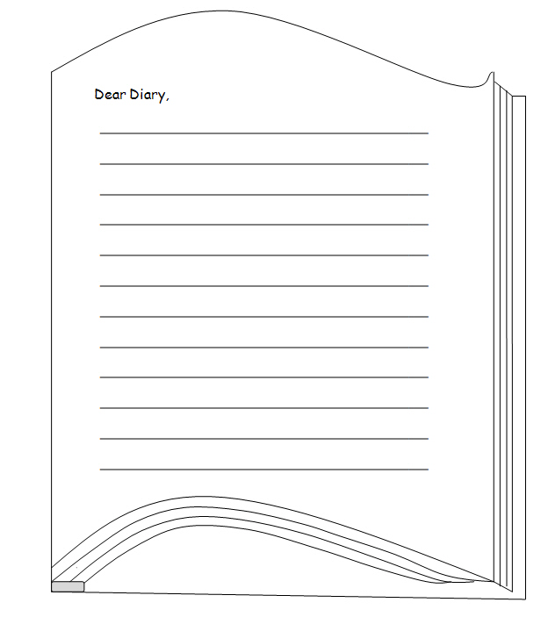

Student Activity Sheet: H1.3 |  | Episode 1: 2008: Laura
Activity 3: Government policy |  | Clip: The apology
Government practice
The removal of Aboriginal and Torres Strait Islander children from their parents was the accepted policy of state and federal governments. In 1997, the Bringing them home Report, which focused on these government practices between 1910 and 1970, was presented to the Parliament of Australia. On 13 February 2008 Prime Minister Kevin Rudd apologised for the pain caused by decades of state-sponsored treatment of Indigenous Australians.
- Listen to or read the speech. It is available at: http://www.aph.gov.au/house/rudd_speech.pdf
- From your research for the timeline leading up to the apology, and in your own words, explain the significance of the apology for Indigenous people, and for all Australians.

Student Activity Sheet: H1.4 |  | Episode 1: 2008: Laura
Activity 4: Symbolism |  | Clip: The apology
Symbols of unity
In the clip, as well as the flag, people have beads, necklaces, ribbons and arm bands in red, yellow and black colours. Many Aboriginal people identify with these colours. Explore the significance and meaning as intended by Harold Thomas, who designed the flag.
- Research the symbolism of the Aboriginal flag and the Torres Strait Islander flags.

- In the clip, people have ribbons, arm bands, badges and jewellery to symbolise unity. Design your own piece of memorabilia that symbolises your support for the apology.

Student Activity Sheet H2.1 |  | Episode 2: 1998: Mohammed
Activity 1: Cricket |  | Clip: Discrimination
KWL chart: history of cricket
- Use the first two columns before you begin your research. Fill in the last column after completing your research.
What I know | What I want to know | What I learned

Student Activity Sheet H2.2 |  | Episode 2: 1998: Mohammed
Activity 2: Australian cricket |  | Clip: Discrimination
Indigenous Australian cricketers
- Choose an era in History and research the contribution of Indigenous cricketers within that era. Here are some time frames to choose from: 1788–1850, 1851–1910, 1911–39, or 1940–2009.
- Present the information on a poster, with images of the cricketers and information about their achievements.
- Keep track of the resources you use by recording them in the table below.
Author/website | Resource title

Year | Contribution

Student Activity Sheet H2.3 |  | Episode 2: 1998: Mohammed
Activity 3: Equality in sport |  | Clip: Discrimination
Australian women in sport
- View the following clip from the Screen Australia website: Women and Sport in Australia, http://dl.screenaustralia.gov.au/module/1494/#about
- Use the spider map below to record your ideas and opinions after viewing the clip. The topic is written in the middle of the spider map. Add the main ideas on the lines radiating out from the centre. Write further details on the horizontal lines.

Spider map
Write main ideas on the slanted lines that connect to the circle. Write details on the branching lines.
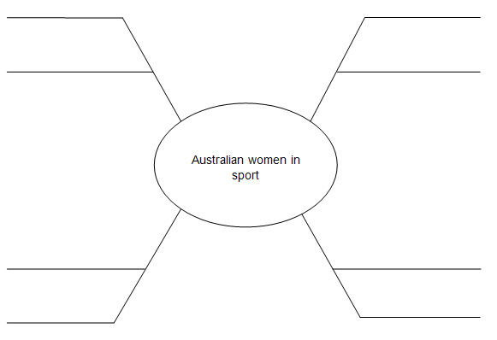
Student Activity Sheet H2.4 |  | Episode 2: 1998: Mohammed
Activity 4: Culture clash |  | Clip: Ramadan
Ramadan facts
- Research and discover more about the traditions of Ramadan. Use the internet and books to find your information and then add keywords that describe the topic to the spokes on the wheel below.

Describing wheel
Add your keywords between the spokes.
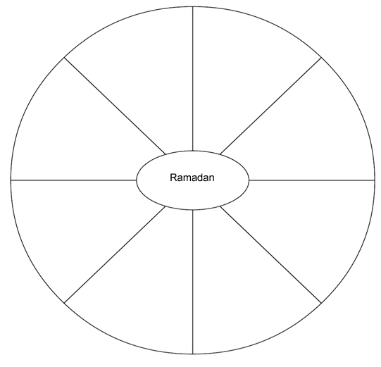
Student Activity Sheet H2.5 |  | Episode 2: 1998: Mohammed
Activity 5: Fasting |  | Clip: Ramadan
Fasting during Ramadan
- Research the topic of fasting during Ramadan and then respond to the following focus questions. Share your findings with an oral presentation to the class.
- What types of foods are eaten during Ramadan?

- Who prepares the food for Ramadan?

- Why are there restrictions on the times food can be eaten?

- When can people break their fast? (This question relates back to Mohammed's grandmother asking whether he will be able to eat before his cricket tryouts.)

- How do families celebrate the end of Ramadan?

Student Activity Sheet H2.6 |  | Episode 2: 1998: Mohammed
Activity 6: Warnie |  | Clip: The ball of the century
'Hall of fame' poster
- Select an Australian sporting legend and create a short biography of your sportsperson. Present your research as a poster with images and text. When your poster is complete it will become a part of a class 'Hall of fame' of Australian sports stars.
- Use the space below to plan your poster.

Student Activity Sheet H3.4 |  | Episode 3: 1988: Lily
Activity 4: Bicentennial celebrations in Australia |  | Clip: The Bicentenary
Bicentennial information pamphlet
- Find out about some different items of merchandise designed to celebrate the Australian Bicentenary and research them. Before and during the Bicentennial celebrations there were commemorative stamps, coins, posters and other products made to mark the occasion. Find information and pictures about these items. The information can be presented as a pamphlet that you make either on a computer or on paper.
- Design and draft your pamphlet below.

Student Activity Sheet H5.6, page 1 of 2 |  | Episode 5: 1968: Sofia
Activity 6: A soldier's life |  | Clip: Conscription
A soldier's journey
- Locate a picture of Michaelis as a soldier in uniform from the My Place 'Stills gallery'.
The picture will be used as part of a storyboard.
- Your story will be about Michaelis going to the Vietnam War as a soldier.
It can be written as a journal entry or a creative piece.
- Research the following key points before beginning the storyboard:
- How were soldiers deployed to Vietnam?
- How long did they have to spend in Vietnam?
- What types of duties were carried out by soldiers in Vietnam?
- What uniform regulations did they need to abide by?
- What were the conditions like in Vietnam?
- Where in Vietnam did they serve? Show on a map.
- Who was decorated with a Victoria Cross during the Vietnam War?
- Draft your text and create a brief outline of the pictures and diagrams you will use to help tell your story. Have this checked by your teacher before moving on to your final storyboard.

Student Activity Sheet H5.6, page 2 of 2 |  | Episode 5: 1968: Sofia
Activity 6: A soldier's life |  | Clip: Conscription
Below is a template of a storyboard and an example of how to begin.
My name is Michaelis and I am getting ready to say goodbye to my family. I will leave for the Vietnam War in two days.

Student Activity Sheet H5.7, page 1 of 2 |  | Episode 5: 1968: Sofia
Activity 7: The swinging ‘60s |  | Clip: Conscription
What's a record?
- Before he leaves for the Vietnam War, Michaelis asks Sofia to look after his record collection while he is away.
- What is a record?

- What do you play it on?

- What different sizes and forms do records have?

- Find images of record players from the 1960s and create a chart of the technology available at the time.
- Research the type of music played in Australia during the 1960s and list the popular bands, singers and musicians. Find out which ones were the most successful in the Top 40 charts. Find examples of record album covers.
'60s bands | '60s singers | '60s musicians

Student Activity Sheet H5.7, page 2 of 2 |  | Episode 5: 1968: Sofia
Activity 7: The swinging ‘60s |  | Clip: Conscription
- Make a compilation album of 12 popular songs from the 1960s. Design a cover for the album.

Student Activity Sheet H6.4 |  | Episode 6: 1958: Michaelis
Activity 4: An Aussie oasis |  | Clip: A Greek garden
The family cookbook
- Create a mini-cookbook with recipes from your own family. Ask family members about traditional recipes that are cooked and baked at home. Think about all of the wonderful meals you have shared with your family during times of celebration. These are the recipes your family will know and love to share. You can also add recipes where all of the ingredients have come from the home garden.
- Add pictures, photos and tips from your parents, grandparents and other family members.
- Research recipes from Greece and find one recipe for an entrée or starter, one for a main meal and one for a dessert. Once you have the recipes together you can combine them all to make a class recipe book. Some useful recipe websites:
- Taste.com.au, http://www.taste.com.au/recipes/collections/greek+recipes
- Dairy Australia, http://www.dairyaustralia.com.au/recipes
- The Heart Foundation, http://www.heartfoundation.org.au/recipes
- Jamie Oliver, http://www.jamieoliver.com
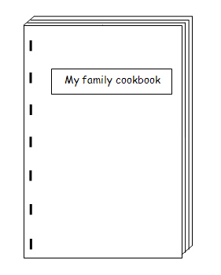
- Choose one recipe from the mini-cookbook and make the meal with a family member at home. Foods can be brought into school and celebrated as part of a multicultural food day, or for Greek Independence Day on 25 March.

Student Activity Sheet H6.5, page 1 of 2 |  | Episode 6: 1958: Michaelis
Activity 5: Gardening |  | Clip: An Aussie oasis
Weekly chores
Michaelis and his father are in their backyard gardening when his mother comes out to admire their work. In 1958, children were expected to work around the house or garden at the direction of their parents. Gardening was just one chore that Michaelis was expected to complete.
- List the chores Michaelis is expected to complete around his home. Compare these to other characters' chores in other episodes such as those below.

Michaelis | Colum | Bridie | Bertie | Rowley | Victoria

- Write a diary entry for a day in the life of Michaelis and explain how you think he feels about the events happening in his life. You can use the 'Dear Diary' template on the next page.
Share these stories with the rest of the class.

Student Activity Sheet H6.5, page 2 of 2 |  | Episode 6: 1958: Michaelis
Activity 5: Gardening |  | Clip: An Aussie oasis

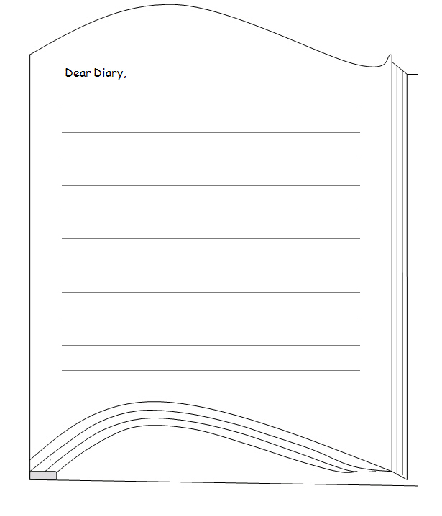

Student Activity Sheet: H6.8 |  | Episode 6: 1958: Michaelis
Activity 8: Paying a penny |  | Clip: The christening
Yesteryear and now
The boys next door who bullied Michaelis repay him a penny for his lost ice block.
- Look at what can be bought in the 1950s and what the cost of an equivalent item is today. Make a comparative list of essential commodities that would be purchased each week by a family, such as bread, milk, butter, cheese, meat, Vegemite, jam and soap.

Commodity | 1958 | 2010
- Design a catalogue for 1958 using images and prices from that era. Find a promotional flyer from a local supermarket advertising this week's grocery specials. These brochures are placed in the letter box, or you can find them on the internet. Use the brochure as a guide for the layout of your 1958 catalogue.
- Produce a price list and illustrate what would be sold at the milk bar that Michaelis visits in this episode. This article from The Age online is a good source of information about how household shopping lists have changed over time:
The Age, 'How CPI shopping list has changed', http://www.theage.com.au/news/national/how-cpi-shopping-list-has-changed/2008/04/23/1208743040371.html

Student Activity Sheet H7.4 |  | Episode 7: 1948: Jen
Activity 4: The FX |  | Clip: Holdens
A model car
- Choose a popular Holden car from the decade you have been given.
- Find or download images of the model you have chosen and draw your own sketches as a draft for your 3D model. Make sure you draw the left and right sides as well as the back and front of the car to get an idea of its three-dimensional design.
- Plan your model car using the table below. Your car can be made out of any materials available, for example, modelling clay or papier mâché.
Decade of Holden car | Name and  model number | Downloaded images | Sketches and notes

Student Activity Sheet H7.7 |  | Episode 7: 1948: Jen
Activity 7: The baby boom |  | Clip: Courting
Charting birth and marriage rates
- Record the rate of births and marriages for the era in History your group has been given. Then add the rates found by the rest of the class and compare the differences. Explain the reason for any changes.
Decade | Births | Marriages | Reason for change
2000s
1990s
1980s
1970s
1960s
1950s
1940s
1930s
1920s
1910s
1900s
1890s
1880s
1870s
1860s
1850s
1840s
1830s
1820s
1810s
1800s
- Find out two other useful pieces of historical information about your group's era and share this with your class.
- Other relevant information from this era:

Student Activity Sheet H7.9 |  | Episode 7: 1948: Jen
Activity 9: A marriage proposal |  | Clip: Courting
Marriage customs
- Is the custom of asking a father for his daughter's hand in marriage still important today in Australian culture? Where did this custom come from and why?

- Select a community with a different cultural background in Australia or another country and research the marriage customs in this culture. Make a poster about what you find out to present to the class. Draft some ideas here.
- Country/culture:

- Information about courting, how marriage is proposed and the marriage ceremony:

Horses
Student Activity Sheet H8.7 |  | Episode 8: 1938: Colum
Activity 7: The Melbourne Cup |  | Clip: Punting
- Investigate information about the Melbourne Cup using a variety of websites and books. List as many facts you can find about the history, people and special events relevant to the Melbourne Cup. You could visit the following websites:
- Australian Government Culture Portal, 'Melbourne Cup', http://www.cultureandrecreation.gov.au/articles/melbournecup
- Melbourne Cup 150, 'Melbourne Cup Carnival 2010', http://www.melbournecup.com
- Victorian Racing Club, 'About the Melbourne Cup', http://www.vrc.net.au/melbourne-cup-carnival/melbourne-cup-statistics.asp
- Present your facts on a series of horse templates, like the one below.
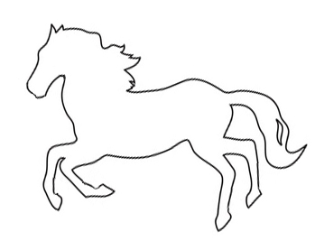

Student Activity Sheet H8.8 |  | Episode 8: 1938: Colum
Activity 8: Winners and losers |  | Clip: Punting
Horse brochure
Imagine you are the owner of a horse that has won the Melbourne Cup and design a brochure about the horse. List its name, nature, characteristics, including height and stature, its owner and their history with horses and success in racing, its trainer and their success and expertise.
- Include information about the colours the horse races in and what symbolism is attached to these 'silks'. Also include information about the jockey.
- Draft some ideas in the space below.
Front:

Back:

Student Activity Sheet H8.9 |  | Episode 8: 1938: Colum
Activity 9: Aussie icon |  | Clip: Punting
Identifying icons
- Answer the following questions:
- What is an icon?

- Devise a list of Australian icons and organise them into the categories below.
Historical | Custom | Sport | Food | People
- Why are these icons revered in Australia?

- Select one icon from the list and work in a small group to devise an advertisement for selling the icon to an overseas audience. This can be an actual enactment of filmed advertisement. Refer to the websites and resources below:
- Australian Children's Television Foundation website for the Learning Centre's 'Live Action Kit', http://www.actf.com.au/learning_centre/title_pages/lia_tp.php
- Screen Australia Digital Learning, 'DIY Doco', http://www.screenaustralia.gov.au/learning/diydoco
- L2844 Lights, camera, action: camera
- L2845 Lights, camera, action: editing
- L2846: Lights, camera, action: lighting
- L2847 Lights, camera, action: sound

Student Activity Sheet H9.4 |  | Episode 9: 1928: Bridie
Activity 4: Mourning |  | Clip: The funeral
Funeral ceremonies
- Different cultures have their own customs and ceremonies to farewell those who have passed away. From the list created in your classroom, choose one culture and investigate their funeral customs and ceremonies.
- Make a small poster, or online document, and include the following elements in your research presentation:
- country of origin
- religious beliefs
- customs for funerals
- beliefs about the afterlife
- other facts.
- Present your information to the class.
Draft your ideas here.

