Episode 4: 1978: Mike
Unit focus: English
Year level: Years 3–6
Episode clip: The card collection
Activity 4: Music and fashion
Subthemes: Art, music and literature; Fashion; Relationships
Discover
- Music is used by the filmmaker to introduce Mike's young aunt Sofia as she plays records in her bedroom with her friend. As a class, discuss why the filmmaker chose to use music to introduce this scene and focus on Sofia when she held a record in her hand as music was played. Was this to indicate her interest in music?
Reflect
- Ask students to create a character profile of Sofia that answers the following questions:
- How is Sofia dressed?
- What type of fashion are her clothes representative of for the era?
- What could have influenced her style?
- What style of music is she listening to?
- What are her likes and dislikes?
- What are her hobbies and interests?
- The character profile can be created using the template from Student Activity Sheet E4.4.
Download
- Student Activity Sheet: E4.4: Character profile on Sofia
Episode 11: 1908: Evelyn
Unit focus: English
Year level: Years 3–6
Episode clip: Games from India
Activity 3: Dressing for play
Subthemes: Fashion; Relationships
Discover
- As a class examine the clothes worn by the characters Evelyn, Edward and Freddie. Ask students to describe what each is wearing and to discuss why they are wearing these outfits for play. Evaluate the suitability of these garments for playing in and compare them to clothes students wear today. Examine the reasons why fashions change.
- During this process complete a class KWLH chart to record evidence of:
- What we Know
- What we Want to know
- What we Learned
- How we learned it.
Reflect
- Locate images of Evelyn, Edward and Freddie in the 'Stills gallery' and download them. Ask the students to paste each one onto a separate sheet of paper. Underneath each image students are to write a description of the character's clothing, as if they were fashion reporters for a newspaper. Ask students to design a new outfit for each character. To begin this task, students should research the fashion styles worn by children of this era. Students should explain how their designs suit the personality of each character.
Download
- Student Activity Sheet: E11.3: Fashion designer
Episode 3: 1988: Lily
Unit focus: History
Year level: Years 3–6
Episode clip: Food and chores
Activity 1: Fashions of the '80s
Subthemes: Fashion; Gender roles
The 1980s saw a buoyant economy that allowed families to afford the latest trends and technological advancements, such as microwave ovens, colour TVs and VHS players. Fashion reflected the notion that women could work as equals to men, and their clothes reflected a more businesslike approach, with bold fabrics, large jewellery and shoulder pads.
Discover
- Discuss the following questions:
- What factors inspired the fashion trends of the 1980s?
- Where did these trends originate?
- Why did Australians want to follow these trends?
- Ask students to find images of fashion items from the 1980s. These images can include clothing, footwear or accessories. The images can form a 1980s mural for the classroom. Discuss the main elements of fashion for men and women in the 1980s.
Reflect
- Ask students to create a fashion inspired by the 1980s. They should use the template provided and find colour and pattern swatches for the outfit.
- As a class, compile a list of the most popular clothing trends from the 1980s.
Download
- Student Activity Sheet H3.1: Fashion template
Episode 11: 1908: Evelyn
Unit focus: History
Year level: Years 3–6
Activity 3: Fashions for children
Subthemes: Fashion; Gender roles and stereotypes
The characters in this episode wear costumes typical of fashions in 1908. Evelyn wears a modest dress of cotton or gingham with long sleeves, a full skirt and a hemline above the ankles. Edward and Freddie wear white shirts, ties, vests, shorts and work boots.
Discover
- Ask students to compare the fashions in the clip with the fashions of children today. For more in-depth information, students can conduct research in the school or local library, or online.
As a starting point, refer to the websites listed below:
- Wikipedia, '1900s in fashion', http://en.wikipedia.org/wiki/1900s_in_fashion
- Fashion-Era, 'Children's Costume History 1900 to 1910', http://www.fashion-era.com/Childrens_clothes/1900_1910_girls_costume_pictures.htm
- The Costume Gallery's Online Library, 'McCall's Magazine: May 1908', http://www.costumegallery.com/McCalls/May_1908/Month.htm
- Students should choose a character from the episode, draw them a costume, name the parts of the costume and describe why they wore this attire. Ask students to design another costume for their chosen character and explain why they have dressed them this way. They could cut out their character as a paper-doll pattern and dress the doll in the new costume using paper tabs. As an alternative, students could use card and magnets to make the designs into paper dolls that they can display on a magnetic surface.
Download
- Student Activity Sheet H11.3: Paper-doll costumes
Episode 13: 1888: Victoria
Unit focus: History
Year level: Years 3–6
Episode clip: Victoria's family supper
Activity 4: The 'It girls'
Subthemes: Fashion; Gender roles and stereotypes
Character profiling can highlight the historical significance of a person's attire. Costumes, work attire and everyday clothing are the pictorial benchmark of an era.
Focus discussion on the characteristics of the Owen girls and the members of Victoria's family. Also note some of the other characters in the episode, for example, Miss Müller. The pop culture idea of an 'It girl' can help students understand why the focus on clothes is important in determining historical status.
Discover
- What makes an It girl in 1888?
Reflect
- Ask students to create character profiles using names, birthdates, descriptions and clothing from 1888. Websites to use include:
- Picture Australia, http://pictureaustralia.org/trail/fashion+trail
- Eureka Council, http://www.eurekacouncil.com.au/Australian-Culture/australian-fashion.htm
- Victorians Fashion Australia, http://www.ulladulla.info/fhc/vicfashions.htm
- Collections Australia: http://www.collectionsaustralia.net/collections
- Students create a character profile using different software programs.
Download
- Student Activity Sheet H13.5: Historical character profile
Student Activity Sheet E4.4 |  | Episode 4: 1978: Mike
Activity 4: Music and fashion |  | Clip: The card collection

Character profile on Sofia
Using your notes from Episode 4, create a character profile on Mike's Aunt Sofia.
Use the template below to help sort your information on Sofia.
Profile picture

Name

Age

Family background

Likes

Dislikes

Hobbies

Musical tastes

Fashion favourites

Student Activity Sheet E11.3 |  | Episode 11: 1908: Evelyn
Activity 3: Dressing for play |  | Clip: Games from India
Fashion designer
- Examine the fashions worn by the characters Evelyn, Edward and Freddie and compare these with clothes children wear today. Make some notes in the table below for use in a class discussion about the topic.
KWLH chart
What I Know | What I Want to know | What I Learned | How I learned it
- Paste images of Evelyn, Edward and Freddie from the 'Stills gallery' onto a separate sheet of paper. Underneath each image write a description of the character's clothes as if you were a fashion reporter for a newspaper.
- Design a new set of clothes for each character. You should first research the fashion styles of the era to get some ideas. Explain how your new clothes will suit the personality of each character.
Evelyn | Edward | Freddie

Student Activity Sheet H3.1 |  | Episode 3: 1988: Lily
Activity 1: Fashions of the '80s |  | Clip: Food and chores
Fashion template
- Create a fashion look inspired by the 1980s. Use the template below to create an outfit. You can use a variety of fabric swatches or coloured paper. Once you have completed your outfit, share it with the class.
- Compile a list of the most popular clothing trends from the 1980s. 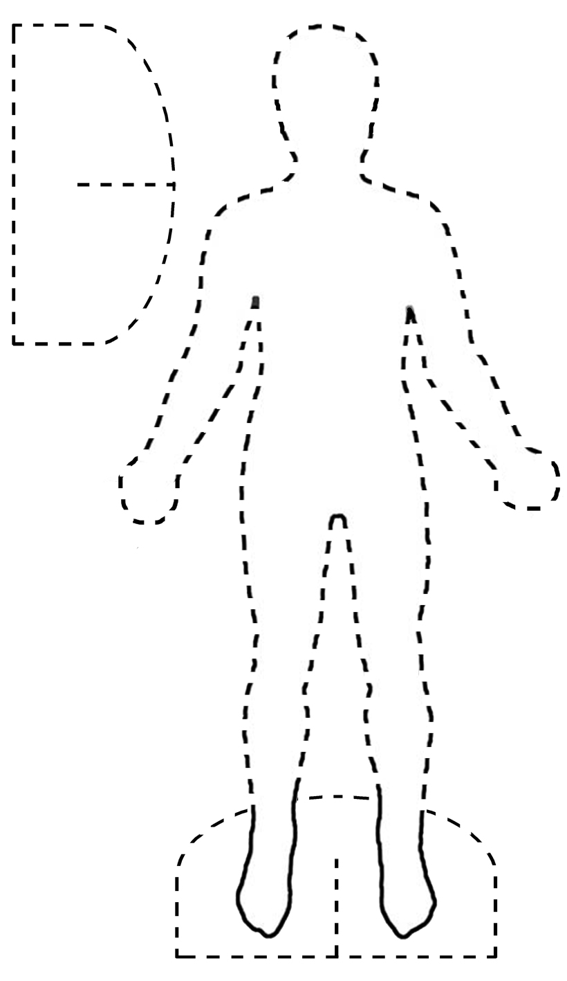

Student Activity Sheet H11.3 |  | Episode 11: 1908: Evelyn
Activity 3: Fashions for children |  | Clip: Games from India
Paper-doll costumes
Create your own outline of a paper doll and make costumes to fit it. The paper doll and costumes can be made using cardboard or felt. You can also create paper dolls on magnetic sheets so that they stick onto a whiteboard or other magnetic surface.
- Dress the doll in the fashions that you would find Evelyn and her siblings wearing.
- Design your own clothes for this era and dress the dolls in these.
Student Activity Sheet H13.5 |  | Episode 13: 1888: Victoria
Activity 4: The 'It girls' |  | Clip 2: Victoria's family supper
Historical character profile
