Episode 3: 1988: Lily
Unit focus: History
Year level: Years 3–6
Episode clip: Food and chores
Activity 1: Fashions of the '80s
Subthemes: Fashion; Gender roles
The 1980s saw a buoyant economy that allowed families to afford the latest trends and technological advancements, such as microwave ovens, colour TVs and VHS players. Fashion reflected the notion that women could work as equals to men, and their clothes reflected a more businesslike approach, with bold fabrics, large jewellery and shoulder pads.
Discover
- Discuss the following questions:
- What factors inspired the fashion trends of the 1980s?
- Where did these trends originate?
- Why did Australians want to follow these trends?
- Ask students to find images of fashion items from the 1980s. These images can include clothing, footwear or accessories. The images can form a 1980s mural for the classroom. Discuss the main elements of fashion for men and women in the 1980s.
Reflect
- Ask students to create a fashion inspired by the 1980s. They should use the template provided and find colour and pattern swatches for the outfit.
- As a class, compile a list of the most popular clothing trends from the 1980s.
Download
- Student Activity Sheet H3.1: Fashion template
Episode 11: 1908: Evelyn
Unit focus: History
Year level: Years 3–6
Activity 3: Fashions for children
Subthemes: Fashion; Gender roles and stereotypes
The characters in this episode wear costumes typical of fashions in 1908. Evelyn wears a modest dress of cotton or gingham with long sleeves, a full skirt and a hemline above the ankles. Edward and Freddie wear white shirts, ties, vests, shorts and work boots.
Discover
- Ask students to compare the fashions in the clip with the fashions of children today. For more in-depth information, students can conduct research in the school or local library, or online.
As a starting point, refer to the websites listed below:
- Wikipedia, '1900s in fashion', http://en.wikipedia.org/wiki/1900s_in_fashion
- Fashion-Era, 'Children's Costume History 1900 to 1910', http://www.fashion-era.com/Childrens_clothes/1900_1910_girls_costume_pictures.htm
- The Costume Gallery's Online Library, 'McCall's Magazine: May 1908', http://www.costumegallery.com/McCalls/May_1908/Month.htm
- Students should choose a character from the episode, draw them a costume, name the parts of the costume and describe why they wore this attire. Ask students to design another costume for their chosen character and explain why they have dressed them this way. They could cut out their character as a paper-doll pattern and dress the doll in the new costume using paper tabs. As an alternative, students could use card and magnets to make the designs into paper dolls that they can display on a magnetic surface.
Download
- Student Activity Sheet H11.3: Paper-doll costumes
Episode 13: 1888: Victoria
Unit focus: History
Year level: Years 3–6
Episode clip: Victoria's family supper
Activity 4: The 'It girls'
Subthemes: Fashion; Gender roles and stereotypes
Character profiling can highlight the historical significance of a person's attire. Costumes, work attire and everyday clothing are the pictorial benchmark of an era.
Focus discussion on the characteristics of the Owen girls and the members of Victoria's family. Also note some of the other characters in the episode, for example, Miss Müller. The pop culture idea of an 'It girl' can help students understand why the focus on clothes is important in determining historical status.
Discover
- What makes an It girl in 1888?
Reflect
- Ask students to create character profiles using names, birthdates, descriptions and clothing from 1888. Websites to use include:
- Picture Australia, http://pictureaustralia.org/trail/fashion+trail
- Eureka Council, http://www.eurekacouncil.com.au/Australian-Culture/australian-fashion.htm
- Victorians Fashion Australia, http://www.ulladulla.info/fhc/vicfashions.htm
- Collections Australia: http://www.collectionsaustralia.net/collections
- Students create a character profile using different software programs.
Download
- Student Activity Sheet H13.5: Historical character profile

Student Activity Sheet H3.1 |  | Episode 3: 1988: Lily
Activity 1: Fashions of the '80s |  | Clip: Food and chores
Fashion template
- Create a fashion look inspired by the 1980s. Use the template below to create an outfit. You can use a variety of fabric swatches or coloured paper. Once you have completed your outfit, share it with the class.
- Compile a list of the most popular clothing trends from the 1980s. 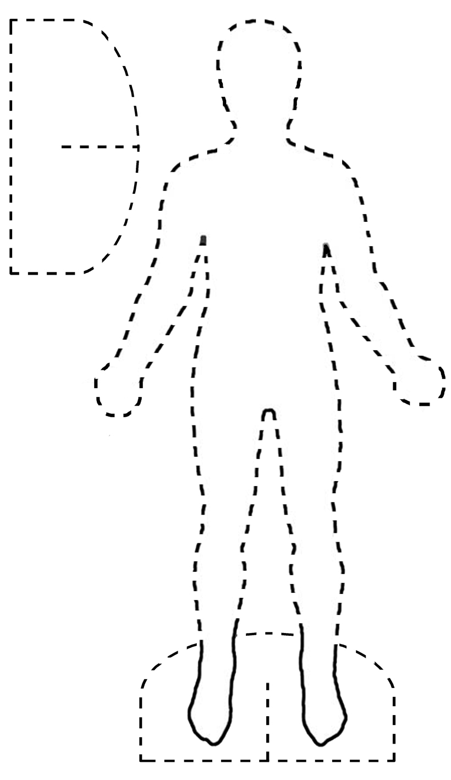

Student Activity Sheet H11.3 |  | Episode 11: 1908: Evelyn
Activity 3: Fashions for children |  | Clip: Games from India
Paper-doll costumes
Create your own outline of a paper doll and make costumes to fit it. The paper doll and costumes can be made using cardboard or felt. You can also create paper dolls on magnetic sheets so that they stick onto a whiteboard or other magnetic surface.
- Dress the doll in the fashions that you would find Evelyn and her siblings wearing.
- Design your own clothes for this era and dress the dolls in these.
Student Activity Sheet H13.5 |  | Episode 13: 1888: Victoria
Activity 4: The 'It girls' |  | Clip 2: Victoria's family supper
Historical character profile
